3GPP TS 29.501 V15.0.1 (2018-07)
Technical Specification
3rd Generation Partnership Project;
Technical Specification Group Core Network and Terminals;
5G System;
Principles and Guidelines for Services Definition;
Stage 3
(Release 15)



The present document has been developed within the 3rd Generation Partnership Project (3GPP TM) and may be further elaborated for the purposes of 3GPP..
The present document has not been subject to any approval process by the 3GPP Organizational Partners and shall not be implemented.
This Specification is provided for future development work within 3GPP only. The Organizational Partners accept no liability for any use of this Specification.
Specifications and Reports for implementation of the 3GPP TM system should be obtained via the 3GPP Organizational Partners' Publications Offices.

Keywords
3GPP, 5GS
3GPP
Postal address

3GPP support office address
650 Route des Lucioles - Sophia Antipolis
Valbonne - FRANCE
Tel.: +33 4 92 94 42 00 Fax: +33 4 93 65 47 16
Internet
http://www.3gpp.org
Copyright Notification
No part may be reproduced except as authorized by written permission.
The copyright and the foregoing restriction extend to reproduction in all media.

© 2018, 3GPP Organizational Partners (ARIB, ATIS, CCSA, ETSI, TSDSI, TTA, TTC).
All rights reserved.

UMTS™ is a Trade Mark of ETSI registered for the benefit of its members
3GPP™ is a Trade Mark of ETSI registered for the benefit of its Members and of the 3GPP Organizational Partners
LTE™ is a Trade Mark of ETSI registered for the benefit of its Members and of the 3GPP Organizational Partners
GSM® and the GSM logo are registered and owned by the GSM Association
Contents
Foreword 6
1 Scope 7
2 References 7
3 Definitions and abbreviations 8
3.1 Definitions 8
3.2 Abbreviations 8
4 Design Principles for 5GC SBI APIs 8
4.1 General Principles 8
4.2 API Design Style and REST Implementation Levels 9
4.2.1 General 9
4.2.2 API Design Principles for Query Operation 9
4.2.3 API Design Principles for Delete Operation 9
4.3 Version Control 10
4.3.1 Structure of API version numbers 10
4.3.1.1 API version number format 10
4.3.1.2 Rules for incrementing field values 10
4.3.1.3 Visibility of the API version number fields 10
4.3.1.4 Relation to the Technical Specification version number 11
4.3.1.5 Discovery of the supported versions 11
4.4 URI Structure 12
4.4.1 Resource URI structure 12
4.4.2 Custom operations URI structure 12
4.4.3 Callback URI structure 12
4.5 Resource Representation and Content Format Negotiation 12
4.5.1 Resource Representation 12
4.5.2 Content Format Negotiation 13
4.6 Use of HTTP Methods 13
4.6.1 Use of Request/Response Communication 13
4.6.1.1 CRUD 13
4.6.1.1.1 Creating a Resource 13
4.6.1.1.1.1 General 13
4.6.1.1.1.2 Creating a Resource using POST 13
4.6.1.1.1.3 Creating a Resource using PUT 14
4.6.1.1.2 Reading a Resource 15
4.6.1.1.2.1 Reading a Single Resource 15
4.6.1.1.2.2 Querying a Set of Resources 15
4.6.1.1.3 Updating a Resource 16
4.6.1.1.3.1 Usage of HTTP PUT 16
4.6.1.1.3.2 Usage of HTTP PATCH 17
4.6.1.1.4 Deleting a Resource 17
4.6.1.1.5 Query Parameters 18
4.6.1.2 Custom Operations 18
4.6.1.3 Use of Asynchronous Operations 18
4.6.1.4 Special provisions to support the seamless change of AMF as NF service producer 18
4.6.2 Use of Subscribe/Notify Communication 19
4.6.2.1 General 19
4.6.2.2 Management of Subscriptions 19
4.6.2.2.1 General 19
4.6.2.2.2 Creation of a Subscription 19
4.6.2.2.3 Modify a subscription 20
4.6.2.2.3.1 Modification of a Subscription Using HTTP PUT 20
4.6.2.2.3.2 Modification of a Subscription Using HTTP PATCH 21
4.6.2.2.4 Delete a subscription 21
4.6.2.3 Notifications 21
4.6.2.4 Special provisions to support the seamless change of AMF as NF service consumer 22
4.7 HATEOAS 22
4.7.1 General 22
4.7.2 3GPP hypermedia format 23
4.7.3 Advertising legitimate application state transitions 24
4.7.4 Inferring link relation semantic 24
4.7.5 Common Relation Types 24
4.7.5.1 Introduction 24
4.7.5.2 Registered relation types 24
4.7.5.3 Extension relation types 25
4.7.6 Negotiating the support of optional HATEOAS features 25
4.8 Error Responses 25
4.9 Transferring multiple resources to a NF Service Consumer 26
4.9.1 General 26
4.9.2 Direct Delivery 26
4.9.3 Direct Delivery with Iterations 26
4.9.4 Indirect Delivery 27
4.9.5 Indirect Delivery with HTTP/2 Server Push 28
4.9.6 Criteria for choosing the transfer method 30
5 Documenting 5GC SBI APIs 30
5.1 Naming Conventions 30
5.1.1 Case Conventions 30
5.1.2 API Naming Conventions 31
5.1.3 Conventions for URI Parts 32
5.1.3.1 Introduction 32
5.1.3.2 URI Path Segment Naming Conventions 32
5.1.3.3 URI Query Naming Conventions 33
5.1.4 Conventions for Names in Data Structures 33
5.2 API Definition 33
5.2.1 Resource Structure 33
5.2.2 Resources and HTTP Methods 34
5.2.3 Representing RPC as Custom Operations on Resources 36
5.2.4 Data Models 38
5.2.4.1 General 38
5.2.4.2 Structured data types 38
5.2.4.3 Simple data types and enumerations 39
5.2.4.4 Binary Data 40
5.2.4.5 Data types describing alternative data types or combinations of data types 40
5.2.5 Relation types 41
5.3 Open API specification files 41
5.3.1 General 41
5.3.2 Formatting of OpenAPI files 41
5.3.3 Info 41
5.3.4 externalDocs 41
5.3.5 Servers 42
5.3.6 References to other 3GPP-defined Open API specification files 42
5.3.7 Server-initiated communication 42
5.3.8 Describing the body of HTTP PATCH requests 43
5.3.8.1 General 43
5.3.8.2 JSON Merge Patch 43
5.3.8.3 JSON PATCH 43
5.3.9 Structured data types 44
5.3.10 Data types describing alternative data types or combinations of data types 45
5.3.11 Error Responses 47
5.3.12 Enumerations 48
Annex A (informative): TS Skeleton Template 49
Annex B (informative): Backward Incompatible Changes 49
Annex C (Informative): Resource modelling 49
C.1 Document 50
C.2 Collection 50
C.3 Store 50
C.4 Custom operation 51
Annex D (informative): Open API example file for Patch 51
Annex E (informative): Change history 54

Foreword
This Technical Specification has been produced by the 3rd Generation Partnership Project (3GPP).
The contents of the present document are subject to continuing work within the TSG and may change following formal TSG approval. Should the TSG modify the contents of the present document, it will be re-released by the TSG with an identifying change of release date and an increase in version number as follows:
Version x.y.z
where:
x the first digit:
1 presented to TSG for information;
2 presented to TSG for approval;
3 or greater indicates TSG approved document under change control.
y the second digit is incremented for all changes of substance, i.e. technical enhancements, corrections, updates, etc.
z the third digit is incremented when editorial only changes have been incorporated in the document.

1 Scope
The present document defines design principles and documentation guidelines for 5GC SBI APIs. These principles and guidelines should be followed when drafting the 5G System SBI Stage 3 specifications.

2 References
The following documents contain provisions which, through reference in this text, constitute provisions of the present document.
- References are either specific (identified by date of publication, edition number, version number, etc.) or non-specific.
- For a specific reference, subsequent revisions do not apply.
- For a non-specific reference, the latest version applies. In the case of a reference to a 3GPP document (including a GSM document), a non-specific reference implicitly refers to the latest version of that document in the same Release as the present document.
[1] 3GPP TR 21.905: "Vocabulary for 3GPP Specifications".
[2] 3GPP TS 29.500: "5G System; Technical Realization of Service Based Architecture; Stage 3".
[3] IETF RFC 8259: "The JavaScript Object Notation (JSON) Data Interchange Format".
[4] OpenAPI: "OpenAPI 3.0.0 Specification", https://github.com/OAI/OpenAPI-Specification/blob/master/versions/3.0.0.md.
[5] 3GPP TS 29.571: "5G System; Common Data Types for Service Based Interfaces Stage 3".
[6] IETF RFC 7231: "Hypertext Transfer Protocol (HTTP/1.1): Semantics and Content"
[7] IETF RFC 7396: "JSON Merge Patch".
[8] IETF RFC 6902: "JavaScript Object Notation (JSON) Patch".
[9] IETF RFC 3986: "Uniform Resource Identifier (URI): Generic Syntax"
[10] IETF RFC 5789: "PATCH Method for HTTP"
[11] IETF RFC 8288: "Web Linking".
[12] IANA: "HTTP Status Code Registry at IANA", http://www.iana.org/assignments/http-status-codes
[13] IETF RFC 7540: "Hypertext Transfer Protocol Version 2 (HTTP/2)"
[14] Fielding, Roy Thomas. Architectural Styles and the Design of Network-based Software Architectures. Doctoral dissertation, University of California, Irvine, 2000.
[15] Erik Wilde, Cesare Pautasso, REST: From Research to Practice, Springer
[16] YAML 1.2: "YAML Ain't Markup Language", http://yaml.org.
[17] Semantic Versioning Specification: https://semver.org
[18] 3GPP TS 29.510: "5G System; Network Function Repository Services; Stage 3".
[19] IETF RFC 7807: "Problem Details for HTTP APIs".
[20] 3GPP TS 29.502: "5G System; Session Management Services; Stage 3".
[21] 3GPP TS 29.509: "Authentication Server Services; Stage 3".

3 Definitions and abbreviations

3.1 Definitions
For the purposes of the present document, the terms and definitions given in 3GPP TR 21.905 [1] and the following apply. A term defined in the present document takes precedence over the definition of the same term, if any, in 3GPP TR 21.905 [1].

3.2 Abbreviations
For the purposes of the present document, the abbreviations given in 3GPP TR 21.905 [1] and the following apply. An abbreviation defined in the present document takes precedence over the definition of the same abbreviation, if any, in 3GPP TR 21.905 [1].
5GC 5G Core Network
HAL Hypertext Application Language
HATEOAS Hypermedia as the Engine of Application State
SBI Service Based Interface
YAML YAML Ain’t Markup Language

4 Design Principles for 5GC SBI APIs

4.1 General Principles
Each 5GC SBI API specification should include the following information for each specified service:
- Purpose of the API;
- URIs of resources;
- Supported HTTP methods for a given resource;
- Supported representations (e.g. JSON, see IETF RFC 8259 [3]);
- Request body schema(s) (where applicable);
- Response body schema(s) (where applicable);
- Supported response status codes;
- Relation types supported if HATEOAS is implemented by the API;
- A reference in the resource description subclause to one of the archetypes defined in Annex C if the resource design matches one of them; and
- A list defining identifiers of optional features (see subclause 6.6 of 3GPP TS 29.500 [2] for related procedures).
For each specified service a subclause to a normative Annex should be provided containing the OpenAPI definitions according to OpenAPI Specification [4] for the service. The specifications should state that content of this normative annex takes precedence when being discrepant to other parts of the specification.
The TS Skeleton Template as provided in Annex A should be used as a starting point when drafting 5GC SBI API specifications.
Common procedures, HTTP extensions and error handling applicable to several 5GC SBI API specifications should be defined in 3GPP TS 29.500 [2] and should be referenced from individual 5GC SBI API specifications.
Common data types applicable to several 5GC SBI API specifications should be defined in 3GPP TS 29.571 [5] and should be referenced from individual 5GC SBI API specifications.

4.2 API Design Style and REST Implementation Levels

4.2.1 General
5GC SBI API specifications should apply a protocol design framework as follows:
a) REST-style service operations should implement the Level 2 of the Richardson maturity model, with standard HTTP methods, whenever it is a good match for the style of interaction to model, e.g. service operations that can naturally map to one of the standard methods (CRUD operations), this should be the preferred modelling attempt;
b) service operations may use custom API operations (RPC-style interaction), when it is seen a better fit for the style of interaction to model, e.g. non-CRUD service operations;
c) it is possible to mix REST-style operations and RPC-style operations in the same API.
NOTE: Level 3 (HATEOAS) of the Richardson maturity model in the 5G Service-Based Architecture can be implemented by an API but is optional. Hypermedia usage guidelines are provided in subclause 4.7 of the present specification.

4.2.2 API Design Principles for Query Operation
When designing a query operation API, i.e. the NF service consumer invokes the API aiming to retrieve certain information from the NF service producer, the following principles should be applied:
a) if the query operation does not require any input parameter for the NF service producer, then the REST-style service operation with standard HTTP GET method should be used (see subclause 4.6.1.1.2);
b) if
- the query operation requires input parameter(s) for the NF service producer; and
- all the required input parameter(s) are used to identify a particular resource and/or control the content of the result of the query operation;
then the REST-style service operation with standard HTTP GET method should be used (see subclause 4.6.1.1.2);
c) standard HTTP GET method shall not be used for non-safe operations and non-idempotent operations.

4.2.3 API Design Principles for Delete Operation
When designing a delete operation API, i.e. the NF service consumer invokes the API aiming to delete certain resource on the NF service producer, the following principles should be applied:
a) if the delete operation does not require any input parameter for the NF service producer, then the REST-style service operation with standard HTTP DELETE method should be used (see subclause 4.6.1.1.4);
b) if
- the delete operation requires input parameter(s) for the NF service producer; and
- all the required input parameter(s) are used to identify a particular resource and/or control the content of the result of the delete operation;
then the REST-style service operation with standard HTTP DELETE method should be used (see subclause 4.6.1.1.4);
c) standard HTTP DELETE method shall not be used for non-idempotent operations.

4.3 Version Control

4.3.1 Structure of API version numbers

4.3.1.1 API version number format
API version numbers shall consist of at least 4 fields, following a MAJOR.MINOR.PATCH pattern as described in the Semantic Versioning Specification [17] with enhancements to cover branches due to 3GPP Releases. Optionally, additional fields can be added after the fourth field.
At the first publication of the 3GPP Technical Specification defining the API, the version number of the API shall be set to "1. Rn.0.0", where n is the number of the 3GPP release.
Editor’s note: It is for further study whether optional fields can be used.

4.3.1.2 Rules for incrementing field values
The fields of an API version number shall be incremented according to the following rules:
- 1st Field (MAJOR): This numerical field shall be incremented when one or more backward incompatible changes to the API.
- 2nd Field (Release): This field corresponds to an 3GPP release and indicates whether the 3GPP Release is still under development. For a 3GPP release that is not yet frozen (i.e. still under development), the field shall take the form "PreRn", where n is the 3GPP release number. For a 3GPP release that is frozen, the field shall take the form "Rn", where n is the 3GPP release number. When the first MAJOR, MINOR or PATCH change in an 3GPP Release is applied to an API, this number shall be set according to that 3GPP release. When a 3GPP Release is being frozen and an "PreRn" release field is assigned to an API, the release field shall be converted to "Rn",
NOTE 1: If no change is applied to an API in a new 3GPP release, the API will maintain the release field of the last 3GPP release where it was changed.
- 3rd Field (MINOR): This numerical field shall be incremented if one or more functionalities are added to the API in a backward compatible manner. This field shall be reset to "0" if the 1st or 2nd field is changed.
- 4th Field (PATCH): This numerical field shall be incremented if one or more corrections are made to the OpenAPI [4] without requiring any change to the API. This field shall be reset to "0" if the 1st 2nd or 3rd field is changed.
NOTE 2: An update of the TS version number in the externalDocs field of the OpenAPI file in the TS is not considered as a PATCH change.
Rules for determining backward incompatible changes are provided in Annex B.
NOTE 3: A mechanism to negotiate the usage of optional features is defined in subclause 6.6 of 3GPP TS 29.500 [2].
Editor’s note: It is for further study whether additional (optional) fields can be used.

4.3.1.3 Visibility of the API version number fields
The API version shall be indicated in the resource URI of every API, as described in subclause 4.4.1.
The API version shall be indicated as the concatenation of the letter "v" and the 1st field of the API version number.
The other fields shall not be included in the resource URI.
NOTE: Including these digits in the URI would force the NF service consumer to select a specific sub-version, at the risk of seeing the request rejected if the NF service provider does not support it, while the request could have been served by ignoring unknown elements.
The full API version number (i.e., containing all the fields) shall be visible in the OpenAPI specifications, in the "version" subfield of the "info" field, as described in subclause 5.3.3.
Editor's note: It is for further study if the full version number can be indicated by a specific version parameter of the Accept HTTP header used in HTTP requests and Content-Type header in the HTTP responses.

4.3.1.4 Relation to the Technical Specification version number
There is no one-to-one mapping between an API version number and the version number of the 3GPP Technical Specification defining this API.
A 3GPP Technical Specification specifies one or more APIs, which may have different versions.
A change in the 3rd field of a 3GPP TS version number (i.e. an editorial change) should not lead to a change in the version number of the APIs specified in the 3GPP TS.
A change in the 1st and 2nd fields of the 3GPP TS version number is likely to lead to at least a change in the minor version number of the APIs specified in the 3GPP TS.
For example, if version 15.4.1 of a 3GPP TS contains version 1.R15.1.1 of API A, B and C, version 16.1.1 of this 3GPP TS can contain version 1.R16.2.1 of API A (if all changes made are backward compatible), version 2.R16.1.1 of API B (if some changes are no backward compatible) and version 1.R15.1.1 of API C (if no changes were made).
Each OpenAPI specification shall provide in an "externalDoc" field the reference to only one 3GPP TS describing the API, including the version number, as illustrated below. The 3GPP TS version is the one in which the API version number has been incremented.
openapi: 3.0.0
info:
title: Nudm_SubscriberDataManagement Service API
description: The Nudm_SubscriberDataManagement Service is used by Consumer NFs to retrieve from the UDM UE's subscription data relevant to the consumer NF and to be notfieid of any change on these data.
version: 1.0.0
license:
name: [TBD]
url: https://[TBD].txt
externalDocs
description: 3GPP TS Unified Data Management Services version 0.5.0
url: http://www.3gpp.org/ftp/Specs/archive/29_series/29.503/29503-050.zip
servers:
- url: https://{apiRoot}/nudm-sdm/v1
…

4.3.1.5 Discovery of the supported versions
The NF service consumer may discover the API version(s) supported by an NF service producer using the following mechanisms:
- NRF query: The NF service consumer may retrieve from the NRF the NF profile of a given NF Instance. This NF profile contains the full version number(s) of the API(s) supported by an NF Service Instance, as described in the subclause 6.2.6.2.4 of 3GPP TS 29.510 [18] and the planned retirement date.
- NF profile change notifications: The NF service consumer may subscribe for NF status change notifications with the NRF as specified in subclause 5.2.2.5 of 3GPP TS 29.510 [18]. The NRF shall notify as specified in subclause 5.2.2.6 of 3GPP TS 29.510 [18], any change to the NF profile which may include updated NF service profile containing the current list of NF services and their versions supported by the NF.
When a new major version is created, the NF service producer shall continue supporting at least the previous major version until a retirement date enabling NF service consumers to migrate to the new version. After expiration of the retirement date, the old major version should be deprecated. The retirement date of an old major version supported by a NF service instance may be updated in the NF profile in the NRF.

4.4 URI Structure

4.4.1 Resource URI structure
Resources are either individual resources, or structured resources that can contain child resources. It is recommended to design each resource following one of the archetypes provided in the Annex C.
A URI uniquely identifies a resource. In the 5GC SBI APIs the resource URI structure shall be specified as follows:
{apiRoot}/{apiName}/{apiVersion}/{apiSpecificResourceUriPart}
"apiRoot" shall be a concatenation of the following parts:
- scheme ("http://" or "https://")
Editor's note: The choice of scheme depends on SA3 requirements.
- authority (host and optional port) as defined in IETF RFC 3986 [9]
- an optional deployment-specific string that starts with a "/" character.
Editor's Note: The use of an optional deployment-specific string is ffs.
"apiName" shall define the name of the API.
"apiVersion" shall indicate the 1st Field (MAJOR) of the version of the API. See also subclause 4.3.1.3.
While "apiRoot", "apiName" and "apiVersion" together define the base URI of the API, each "apiSpecificResourceUriPart" defines a resource URI of the API relative to the base URI.

4.4.2 Custom operations URI structure
The custom operation definition is in Annex C.
The URI of a custom operation which is associated with a resource shall have the following structure:
{apiRoot}/{apiName}/{apiVersion}/{apiSpecificResourceUriPart}/{custOpName}
Custom operations can also be associated with the service instead of a resource. The URI of a custom operation which is not associated with a resource shall have the following structure:
{apiRoot}/{apiName}/{apiVersion}/{custOpName}
In the above URI structures, "apiRoot", "apiName", "apiVersion" and "apiSpecificResourceUriPart" are as defined in clause 4.4.1 and "custOpName" represents the name of the custom operation as defined in clause 5.1.3.2.

4.4.3 Callback URI structure
The callback URI shall be in the form of an absolute URI as defined in subclause 4.3 of IETF RFC 3986 [9], including an authority, and excluding any query component, any fragment component and any userinfo subcomponent.

4.5 Resource Representation and Content Format Negotiation

4.5.1 Resource Representation
A resource representation is a serialization of the resource state in a particular content format. It's included in the data frame of an HTTP/2 request or response. Representation header fields provide metadata about the representation. When a message includes a data frame, the representation data enclosed in the data frame. HTTP/2 reuses the definition of Representation header as HTTP 1.1 in IETF RFC 7231 [6]. Content-type field in HTTP/2 header performs as representation header fields and describes the representation data that would have been enclosed in the data frame, e.g. if content-type is application/json, resource representation in data frame is serialized in JSON format.
Server supports the content format of the representation received in the data frame of the request and returns the "200 OK" response code.

4.5.2 Content Format Negotiation
IETF RFC 7231 [6] provides a mechanism to negotiate the content format of a representation.
In HTTP/2 requests and responses, the "Content-Type" HTTP/2 header field is used to signal the format of the actual representation included in the data frame. If the format of the representation in an HTTP/2 request is not supported by the server, it responds with the "415 Unsupported Media Type" response code.
For GET method, the "Accept" HTTP header of the HTTP/2 request signals the content formats that a client supports. If the server cannot provide any of the accepted formats, it returns the "406 Not Acceptable" response code.

4.6 Use of HTTP Methods
This clause provides guidelines on use of HTTP Methods.

4.6.1 Use of Request/Response Communication

4.6.1.1 CRUD

4.6.1.1.1 Creating a Resource

4.6.1.1.1.1 General
Procedures that allow an NF service consumer to create a new resource at the NF service producer shall be specified to either use the HTTP POST method with procedures according to subclause 4.6.1.1.1.2 or the HTTP PUT method with procedures according to subclause 4.6.1.1.1.3.

4.6.1.1.1.2 Creating a Resource using POST
The HTTP POST method (see IETF RFC 7231 [6]) allows an NF service consumer to create a new child resource at the NF service producer in such a manner that the NF service producer selects the child resource identifier and the URI for the child resource.
Figure 4.6.1.1.1.2-1 illustrates creating a resource using POST.
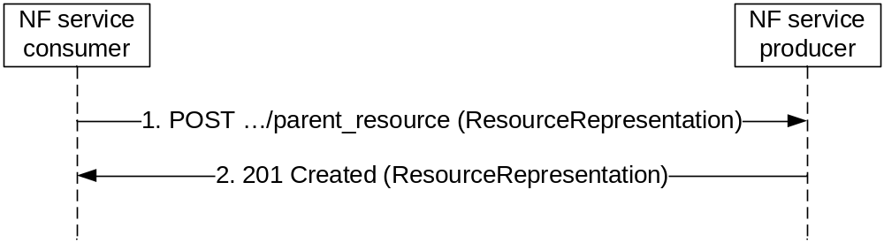
Figure 4.6.1.1.1.2-1: Creating a resource using POST
1. The parent resource of which the new resource is to be created as a child is identified by the request URI. The payload body of the POST request shall contain a representation of the resource to be created without a child resource identifier.
2. The NF service producer generates a child resource identifier and constructs the URI for the created resource by appending that child resource identifier to the parent resource URI received as request URI of the POST request (e.g. "…/parent-resource/childresouce1"). On success, "201 Created" shall be returned, the payload body of the POST response should contain a representation of the created resource, and the "Location" header shall be present and shall contain the URI of the created resource.
NOTE: The representations of the resource in the request and response can differ, e.g. the representation of the resource in the response can be empty or can contain a subset of the representation as received in the request possibly with modified attributes, and in addition can contain additional attributes. Exact details will be specified by the application.
Editor’s Note: The use of partial representation in POST responses should be clarified.
On failure, the appropriate HTTP status code indicating the error shall be returned and appropriate additional error information should be returned in the POST response body (see subclause 4.8).

4.6.1.1.1.3 Creating a Resource using PUT
The HTTP PUT method (see IETF RFC 7231 [6]) allows an NF service consumer to create a new resource at the NF service producer in such a manner that the NF service consumer selects the resource identifier and the URI for the resource.
Figure 4.6.1.1.1.3-1 illustrates creating a resource using HTTP PUT.
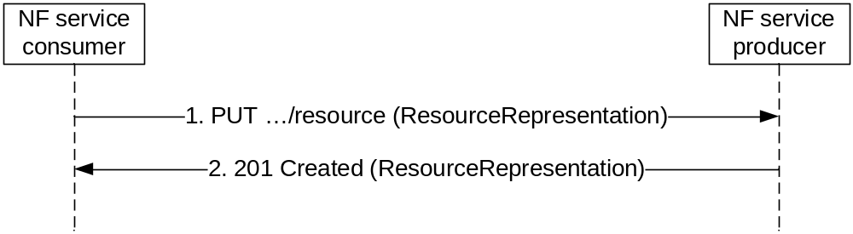
Figure 4.6.1.1.1.3-1: Creating a Resource using HTTP PUT
1. The NF service consumer selects a resource identifier and constructs the URI for the resource to be created by appending that resource identifier to the parent resource URI. The resource that is to be created is identified by that URI as request URI. The payload body of the PUT request shall contain a representation of the resource to be created.
2. On success, "201 Created" shall be returned, the payload body of the PUT response should contain the representation of the created resource, and the "Location" header shall be present and shall contain the URI of the created resource.
NOTE: The representations of the resource in the request and response can differ, e.g. the representation of the resource in the response can be empty or can contain a subset of the representation as received in the request possibly with modified attributes, and in addition can contain additional attributes. Exact details will be specified by the application.
On failure, the appropriate HTTP status code indicating the error shall be returned and appropriate additional error information should be returned in the PUT response body (see subclause 4.8).
If the resource that is to be created already exists at the NF service producer, the following applies:
1) If the update of that resource by PUT is supported, the existing representation of the resource is replaced with the representation received in the PUT request body; see subclause 4.6.1.1.3.1.
2) If the update of that resource by PUT is not supported, the "403 Forbidden" HTTP status code shall be returned and appropriate additional error information should be returned in the PUT response body (see subclause 4.8).

4.6.1.1.2 Reading a Resource

4.6.1.1.2.1 Reading a Single Resource
Procedures that allow a service consumer NF (client) to read information from the server shall be specified to use the HTTP GET method (see IETF RFC 7231 [6]) to obtain the current representation of a resource.
Figure 4.6.1.1.2-1 illustrates reading a resource.
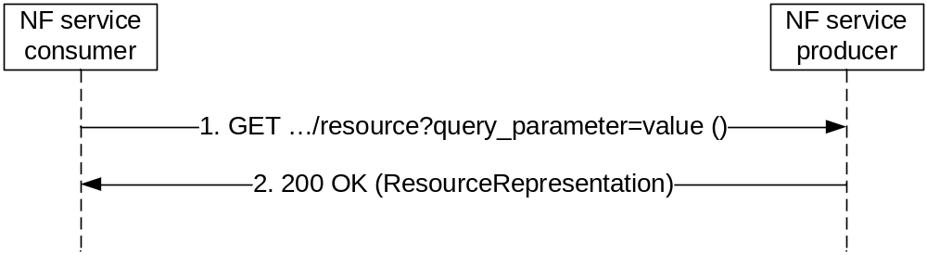
Figure 4.6.1.1.2.1-1: Reading a resource
1. The resource of which a representation is to be obtained is identified by the request URI. Query parameters may be used to control the content of the result.
Editor’s Note: Exact limits for number and length of query parameters are ffs.
Editor’s Note: Alternatives to the GET method for cases where the limits for number and length of query parameters are exceeded are ffs.
The payload body of the GET request shall be empty.
2. On success, "200 OK" shall be returned and the payload body of the GET response shall contain the obtained resource representation.
On failure, the appropriate HTTP status code indicating the error shall be returned and appropriate additional error information should be returned in the GET response body (see subclause 4.8).

4.6.1.1.2.2 Querying a Set of Resources
Procedures that allow a service consumer NF (client) to querying a set of resources from the server shall be specified to use HTTP GET method towards a resource modelled as Collection or Store archetype.
Query parameters (see subclause 4.6.1.1.5) may be provided when querying a set of resources. The query component contains non-hierarchical data that, along with data in the path component, to filter the resources identified within the scope of the URI's scheme to a subset of the resources matching the query parameters. The query component is indicated by the first question mark ("?") character and terminated by a number sign ("#") character or by the end of the URI.
When a server receives a request with query component, it may parse the query string in order to identify filters. The first question mark is used to be a separator and is not part of the query string. And query string is composed of a series of "key=value" pairs.

Editor's note: Whether need and how to define complex syntax rules like operation priority and so on is FFS.
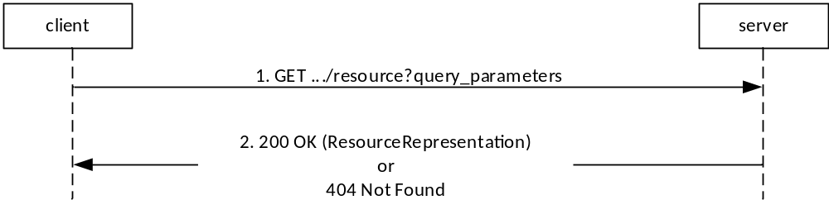
Figure 4.6.1.1.2.2-1 illustrates querying a collection of resources by using query parameters.
Step 1. The client shall send a HTTP GET request using the URI of a resource modelled as Collection or Store archetype, optionally with query parameters, to the server.
Step 2. On success, the server shall return a set of sub-resources that includes only those entries filtered by the query parameters. If no sub-resource is matched for the querying service operation, the server shall return "200 OK" with an empty array (e.g. "[ ]" in JSON) in response body. If the resource in the URI doesn’t exist on the server, the server shall return "404 Not Found" with optionally the cause information in response body.
NOTE: The result array/empty array can be defined as an attribute of an object, if the service operation returns an object in the response payload for extensibility consideration.
Subclause 4.9 specifies some possible options for an NF Service Producer to return the representations of multiple resources to a NF Service Consumer.

4.6.1.1.3 Updating a Resource

4.6.1.1.3.1 Usage of HTTP PUT
Procedures that allow a service consumer NF (client) to update information stored at the server by means of a complete replacement shall be specified to use the HTTP PUT method to replace the current representation of a resource with a new representation.
Figure 4.6.1.1.3.1-1 illustrates updating a resource using HTTP PUT.
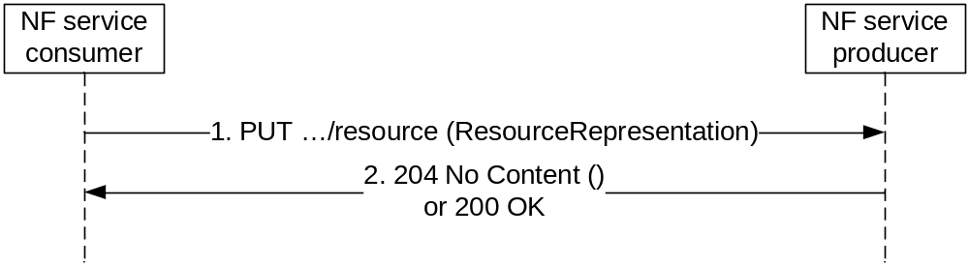
Figure 4.6.1.1.3.1-1: Updating a Resource using HTTP PUT
1. The resource that is to be updated is identified by the request URI. The payload body of the PUT request shall contain the new representation of the resource.
2. On success, "204 No Content" or "200 OK" shall be returned.
On failure, the appropriate HTTP status code indicating the error shall be returned and appropriate additional error information should be returned in the PUT response body (see subclause 4.8).
If the resource that is to be updated does not exist at the NF service producer, the following applies:
1. If the creation of that resource by PUT is supported, the resource is created according to the procedure in subclause 4.6.1.1.1.3.
2. If the creation of that resource by PUT is not supported, the "403 Forbidden" HTTP status code shall be returned and appropriate additional error information should be returned in the PUT response body (see subclause 4.8).

4.6.1.1.3.2 Usage of HTTP PATCH
Procedures that allow a service consumer NF (client) to update information stored at the server by means of a partial replacement shall be specified to use the HTTP PATCH method (see IETF RFC 5789 [10]) to modify the current representation of a resource according to given modification instructions. The format of the PATCH message body shall be specified for each resource where the PATCH method is supported using one or several of the following encodings:
- If no modification of individual elements within an array needs to be supported, the "JSON Merge Patch" encoding of changes defined in IETF RFC 7396 [7] should be used.
- If a modification of individual elements within an array needs to be supported, the "JSON Patch" encoding of changes defined in IETF RFC 6902 [8] shall be used.
A single of the above encodings shall be specified for each resource where the PATCH method is supported unless backward compatibility considerations necessitate the support of both encodings.
NOTE 1: In Rel-15 a single encoding will be selected for each resource as backward compatibility considerations do not yet apply.
NOTE 2: "JSON Merge Patch" does not support the modification of individual elements within an array. However, it supports the modification of individual elements within maps (see subclause 5.2.4.2). Collections of elements can be modelled as maps, instead of arrays, if a partial modification using PATCH is desired.
NOTE 3: The Open API description of the body of HTTP PATCH requests is specified in subclause 5.3.8.
Figure 4.6.1.1.3.2-1 illustrates updating a resource using HTTP PATCH.
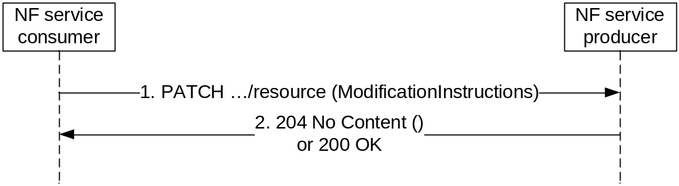
Figure 4.6.1.1.3.2-1: Updating a Resource using HTTP PATCH
1. The resource that is to be updated is identified by the request URI. The payload body of the PATCH request shall contain a description of the requested modifications of the resource. For the "JSON Merge Patch" encoding defined in IETF RFC 7396 [7] and the "Content-Type" header shall be set to "application/merge-patch+json". For the "JSON Patch" encoding of changes defined in IETF RFC 6902 [8] the "Content-Type" header shall be set to "application/json-patch+json".
2. On success, "204 No Content" or "200 OK" shall be returned.
On failure, the appropriate HTTP status code indicating the error shall be returned and appropriate additional error information should be returned in the PATCH response body (see subclause 4.8).

4.6.1.1.4 Deleting a Resource
Procedures that allow a service consumer NF (client) to delete a resource from the server shall be specified to use the HTTP DELETE method (see IETF RFC 7231 [6]).
Figure 4.6.1.1.4-1 illustrates deleting a resource.
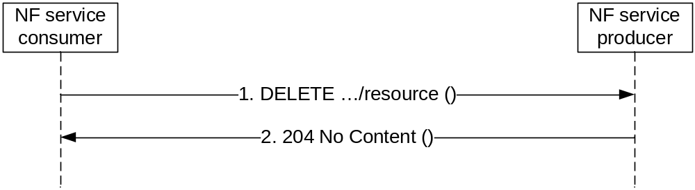
Figure 4.6.1.1.4-1: Deleting a resource
The resource that is to be deleted is identified by the request URI.
The payload body of the DELETE request shall be empty.
On success, "204 No Content" should be returned and then the payload body of the DELETE response shall be empty.
Editor's Note: It is ffs whether "200 OK"may be returned on success and what the payload body of the DELETE response shall contain if so.
On failure, the appropriate HTTP status code indicating the error shall be returned and appropriate additional error information should be returned in the DELETE response body (see subclause 4.8).

4.6.1.1.5 Query Parameters
The query component in the URI contains non-hierarchical data that, along with data in the path component, to filter the resources identified within the scope of the URI's scheme to a subset of the resources matching the query parameters. The query component is indicated by the first question mark ("?") character and terminated by a number sign ("#") character or by the end of the URI. The syntax of the query component is specified in IETF RFC 3986 [9].
When a server receives a request with a query component, it shall parse the query string in order to identify filters. The first question mark is used to be a separator and is not part of the query string. A query string is composed of a series of "key=value" pairs, separated by "&". If one query parameter contains more than one value, i.e. an array of data elements, different values shall be separated by comma (",").

4.6.1.2 Custom Operations

4.6.1.3 Use of Asynchronous Operations
Certain service operations may be designed to allow the invocation of a request so that the response can be received asynchronously: if the NF service consumer when sending a request cannot expect to receive an immediate final response, the service consumer may provide a callback reference for final result notification. The service provider, when receiving a request that contains a callback reference for final result notification, may then return an immediate "202 Accepted", and notify the service consumer about the final result using the received callback reference at a later point in time.

4.6.1.4 Special provisions to support the seamless change of AMF as NF service producer
Services provided by the AMF can be transferred seamlessly to a new AMF when the corresponding UE context is transferred to that AMF.
To support a seamless change of the AMF as NF service producer, the procedures in subclause 4.6.1 are applied with the following special provisions:
1. When becoming aware that a new AMF is serving the resource, the NF service consumer shall exchange the authority part of resource URIs with the address of a new NF service producer and shall use that URI in subsequent communication.
NOTE: An NF service consumer can become aware of an AMF change via Namf_Communication service AMFStatusChange Notifications, via Error response from old AMF, via link level failures (e.g. no response from the AMF), or via a notification from the NRF that the AMF has deregistered. and can then determine the new AMF either via information received within those services or by selecting an AMF from an earlier received AMF set or the backup AMF.
2. Each AMF within a set of AMFs supporting seamless changes shall be prepared to receive updates for resource URIs constructed according to bullet 1 with the own IP address as authority part from the NF service consumer, by either handling the updates, or by replying with an HTTP "307 temporary redirect" error response pointing to new NF service producer, or by replying with another HTTP error such as an "404 Not found".
3. For a service that includes notifications from the AMF, the NF service consumer shall be prepared to receive notifications for the that service from any NF service producer within a set of NF service producers supporting seamless changes

4.6.2 Use of Subscribe/Notify Communication

4.6.2.1 General
Subscribe/Notify communication between 5GC NFs can be used to keep involved NFs (consumers of a service) informed of data changes or events that occur at another NF (producer of the service). A notification is a message that contains information about the event.
Service consumer NFs (clients) need to subscribe to notifications at the service provider NF (server). This either happens explicitly by means of creating a new subscription resource (see subclause 4.6.2.2), or implicitly by updating a relevant resource.
When the change/event occurs at the service producer NF, notifications (see subclause 4.6.2.3) are sent from the service producer NF to the service consumer NFs. This communication initiated by the service producer to the service consumers requires that the service consumer NF (client) takes the role of an HTTP server and the service producer NF (server) takes the role of an HTTP client.
During the explicit subscription the service consumer NF (client) provides a callback URI and possibly additional filter criteria to the service producer NF (server). When the data-change/event occurs that matches the filter criteria in the subscription, the service producer NF (taking the role of an HTTP client) uses the provided callback URI to notify the service consumer NF (taking the role of an HTTP server) about the change.

4.6.2.2 Management of Subscriptions

4.6.2.2.1 General
The HTTP method to create a subscription shall be POST. The HTTP method to modify a subscription shall be PUT or PATCH. The HTTP method to delete a subscription (i.e. to unsubscribe) shall be DELETE (see IETF RFC 7231 [6]).
Subscriptions may be implicit, i.e. exist without being explicitly created. Implicit subscriptions cannot be deleted but can be modified, suspended or resumed as a side effect of other operations.
Editor's Note: It is ffs whether an implicit subscription can be modified by a service that is different from the service to which the notification belongs.
As an example, at the UDM the registered AMF is implicitly subscribed to notification about subscriber data changes as side effect of the registration. When no AMF is registered, the implicit subscription is suspended. When an AMF registers, a suspended subscription is resumed (and updated). At AMF change the implicit subscription is modified. At AMF deregistration (purge) the implicit subscription is suspended.

4.6.2.2.2 Creation of a Subscription
Figure 4.6.2.2.2-1 illustrates explicit creation of a subscription.
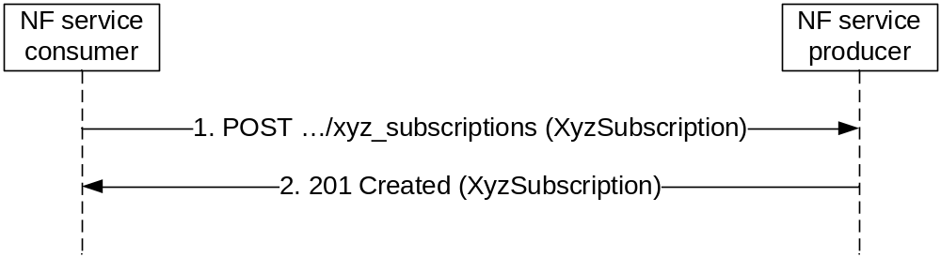
Figure 4.6.2.2.2-1: Creation of a subscription
The parent resource (collection of subscriptions) is identified by the request URI.
The data structure in the payload body of the POST request shall contain a callback URI, and may contain additional criteria to filter the set of events that trigger a notification.
On success, "201 Created" shall be returned, the payload body of the POST response shall contain a representation of the created subscription, and the "Location" header shall contain the URI of the created resource.
On failure, the appropriate HTTP status code indicating the error shall be returned and appropriate additional error information should be returned in the POST response body (see subclause 4.9).

4.6.2.2.3 Modify a subscription

4.6.2.2.3.1 Modification of a Subscription Using HTTP PUT
Procedures that allow a NF service consumer to update the subscription at the server by means of a complete replacement shall use the HTTP PUT method to replace the current subscription with a new representation.
Figure 4.6.2.2.3.1-1 illustrates modification a subscription using HTTP PUT.
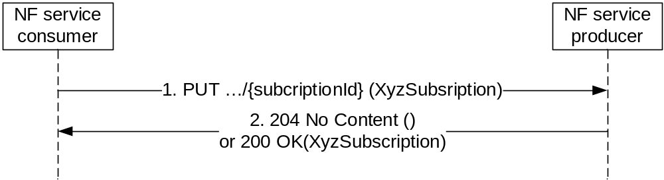
Figure 4.6.2.2.3.1-1: Modification a subscription using HTTP PUT
1. The NF Service Consumer shall send a PUT request to the resource URI representing the individual subscription. The payload body of the PUT request shall contain the subscription information to be replaced including the criteria to filter the set of events that trigger a notification.
2. On success, "204 No Content" without any response body or "200 OK" with a response body providing current resource representation shall be returned.
On failure, the appropriate HTTP status code indicating the error shall be returned and appropriate additional error information should be returned in the PUT response body (see subclause 4.8).
If the NF Service Consumer is not allowed to update the subscription information, the "403 Forbidden" HTTP status code shall be returned and appropriate additional error information should be returned in the PUT response body (see subclause 4.8).
If the resource that is to be updated does not exist at the NF service producer, the "404 Not Found" HTTP status code shall be returned.

4.6.2.2.3.2 Modification of a Subscription Using HTTP PATCH
Procedures that allow a NF service consumer to update subscription at the server by means of a partial replacement shall use the HTTP PATCH method (see IETF RFC 5789 [10]) to modify the current subscription according to given modification instructions.
Figure 4.6.2.2.3.2-1 illustrates updating a resource using HTTP PATCH.
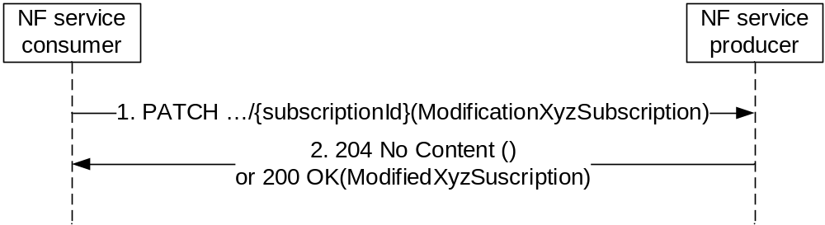
Figure 4.6.2.2.3.2-1: Modification a subscription using HTTP PATCH
1. The NF Service Consumer shall send a PATCH request to the resource URI representing the individual subscription. The payload body of the PATCH request shall contain the modification instructions.
2. On success, "204 No Content" without any response body or "200 OK" with a response body containing the modified subscription information shall be returned.
On failure, the appropriate HTTP status code indicating the error shall be returned and appropriate additional error information should be returned in the PATCH response body (see subclause 4.8).

4.6.2.2.4 Delete a subscription
Figure 4.6.2.2.4-1 illustrates explicit deletion of a subscription.
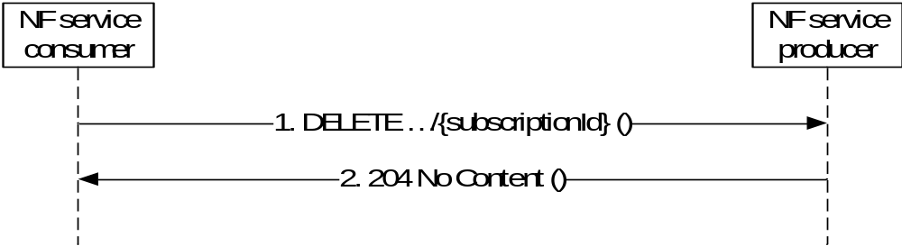
Figure 4.6.2.2.4-1: Deletion of a subscription
1. The NF Service Consumer shall send a DELETE request to the resource URI representing the individual subscription. The request body shall be empty.
2. On success, "204 No Content" shall be returned. The response body shall be empty.
On failure, the appropriate HTTP status code indicating the error shall be returned in the DELETE response body (see subclause 4.8).

4.6.2.3 Notifications
The HTTP method for the notification that corresponds to an explicit subscription shall be POST (see IETF RFC 7231 [6]).
NOTE: Subclause 5.3.7 describes how to encode Notifications in OpenAPI specification files.
Figure 4.6.2.3-1 illustrates a notification.
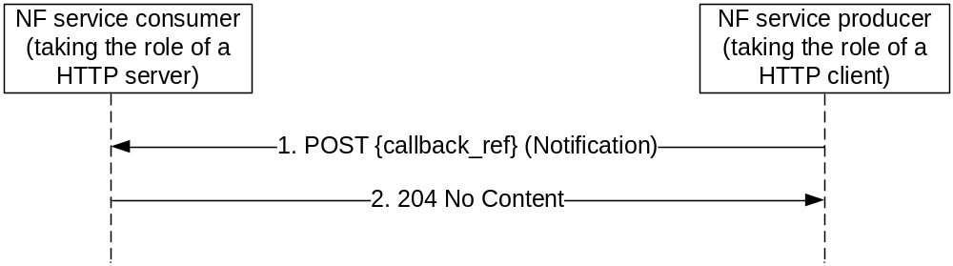
Figure 4.6.2.3-1: Notification
1. The callback reference provided during creation of the subscription resource, or otherwise known from implicit subscription, is used as the request URI. The callback reference for implicit subscriptions are obtained from the NRF. When an NF / NF service registers with the NRF, the default notification subscriptions along with the callback URI for receiving those notifications may be provided (see subclause 6.1.6.2.3 of 3GPP TS 29.510 [18]).
The payload body of the POST request shall contain the notification payload.
2. On success, "204 No Content" shall be returned and the payload body of the POST response shall be empty.
Editor's Note: It is ffs whether "200 OK"may be returned on success and what the payload body of the DELETE response shall contain if so.
On failure, the appropriate HTTP status code indicating the error shall be returned and appropriate additional error information should be returned in the PUT response body (see subclause 4.8).

4.6.2.4 Special provisions to support the seamless change of AMF as NF service consumer
Services consumed by an AMF can be transferred seamlessly to a new AMF when the corresponding UE context is transferred to that AMF.
To support a seamless change of AMF as NF service consumer, the procedures in subclause 4.6.2 are applied with the following special provisions:
1. When becoming aware that a new AMF is requiring notifications related to a subscription resource, the NF service producer shall exchange the authority part of the corresponding Notification URI with the address of that new NF service consumer and shall use that URI in subsequent communication.
NOTE: An NF service producer can become aware of an AMF change via Namf_Communication service AMFStatusChange Notifications, via Error response from old AMF, via link level failures (e.g no response from the AMF), or via a notification from the NRF that the AMF has deregistered. and can then determine the new AMF either via information received within those services or selecting an AMF from an earlier received AMF set or the backup AMF.
2. Each AMF within a set of AMFs supporting seamless changes shall be prepared to receive notifications at the Notification URI constructed according to bullet 1 with the own IP address as authority part from the NF service producer, by either handling the notifications, or by replying with an HTTP "307 temporary redirect" error response pointing to new NF service consumer, or by replying with another HTTP error such as an "404 Not found".

4.7 HATEOAS

4.7.1 General
As defined in [14], HATEOAS stands for Hypermedia As The Engine Of Application State. It means that the hypermedia models application state transitions and describe application protocols.
As defined in [15] chapter 3 RESTful Domain Application Protocols, an application is a software implementation defined to achieve a particular goal. It consists of a set of constrained interactions between NF Service Consumer and Producer performed at run-time that are guided by an application specific set of rules. The application transits across some intermediate states until the application’s goal is achieved. The application has then reached its final state.
An application state is a snapshot of an application instance.
On each interaction, the NF Service Consumer and Producer exchange representations of resource state. According to [14], "REST concentrates all of the control state into the representations received in response to interactions." and "The model application is therefore an engine that moves from one state to the next by examining and choosing from among the alternative state transitions in the current set of representations." After each interaction the NF Service Consumer is then presented with control state options to interact with additional resources. These control states are in the form of hypermedia markups embedded in the returned resource representation. The application state changes when an NF Service Consumer examines and chooses which control to operate and subsequently interacts with the resources identified in the selected control state.
HATEOAS support is optional. If HATEOAS is supported, the procedure in the present subclause 4.7 shall apply.

4.7.2 3GPP hypermedia format
NOTE 1: 3GPP hypermedia format is derived from Hypertext Application Language (HAL). HAL is specified in an expired internet draft available at "https://tools.ietf.org/html/draft-kelly-json-hal-08".
3GPP hypermedia format specifies the following optional reserved properties (see 3GPP TS 29.571 [5] for the complete list and definition of objects and object members):
- "_links": contains links to other resources and expresses valid state transitions.
A NF service producer shall construct a 3GPP hypermedia document by taking a 3GPP defined JSON object attribute list and then adding a "_links" attribute.
Table 4.7.2-1: _links attribute
Attribute name | Data type | P | Cardinality | Description
_links | map(LinksValueSchema) | C | 0..N | _links attribute to be added into the JSON hypermedia object definition

The LinksValueSchema data type shall be added to the list of re-used data types of the hypermedia enabled API (see 3GPP TS 29.509 [21] for an example of implementation of a hypermedia API).
NOTE 2: Depending of the applicable situation, the presence condition and the cardinality can be changed in accordance. LinksValueSchema data type is defined in 3GPP TS 29.571 [5].
The "_links" member names are link relation types (as defined by IETF RFC 8288 [11]) and values are either a "link" object or an array of "link" objects.
3GPP hypermedia format specifies the following "link" attribute:
- "href": contains the URI of the linked resource.
A NF service producer shall set the Content-Type HTTP header to "3gppHal+json" when returning an HTTP payload with a hypermedia enabled document.
Editor’s Note: 3GPP will have to register his hypermedia to IANA.
A NF service consumer supporting HATEOAS shall advertise it by adding an "Accept" HTTP header with "3GPP hypermedia IANA registered media type".
NOTE 3: The HATEOAS principle relies on NF Service Producer providing control state options (_links objects) embedded in the returned resource representation to the NF Service Consumer. An NF Service Consumer may decide to use the format of the _links attribute in HTTP requests to transfer URIs. This is beyond the scope of HATEOAS and another content type than "3gppHal+json" such as "application/Json" can be used.

4.7.3 Advertising legitimate application state transitions
When a NF service producer responds to a NF service consumer and there is one or more application state transition possible, the NF service producer shall advertise them by adding a "_links" property in the returned resource representation. When there are multiple state transitions with different relation types, then one member per relation type shall be added to the "_links" object which name is equal to the relation type. If there is only one state transition for a given relation type then the value of the member is a "link" object otherwise it is an array of "link" objects.
A NF service producer shall include a link into the returned resource representation with a registered relation type "self" when it is expected further actions upon it (for instance reading it again or replacing the resource state).
NOTE 1: For a hypermedia application, a returned representation without any link denotes for the NF service consumers the end of the interaction with the NF service producer. 3GPP APIs does not fulfil this rule.

4.7.4 Inferring link relation semantic
When a NF service consumer receives a response with linked resources then it shall infer the link relation semantic from the relation type. It shall not infer it from the linked resource URI format.
In 3GPP hypermedia, relation types are the name of "_links" object members.

4.7.5 Common Relation Types

4.7.5.1 Introduction
This subclause contains the list of relation types supported in 3GPP Service Based Interface APIs.
As defined in IETF RFC 8288 [11] clause 2.1, a link relation type identifies the semantics of a link. It describes how resources are related to each other. It may also be used to indicate that the target resource of a link has particular attributes, or exhibits particular behaviours. Relation types shall not be confused with media types. It does not identify the format of the representation that results when the link is dereferenced.
There are two kinds of relation types:
- Registered relation types;
- Extension relation types.
Registered relation types are identified by a token (for instance "self") and can be reused by other applications such as 3GPP SBI APIs. They are registered by IANA. Registered relation types shall be preferred against extension relation types when expressing the link relation between two resources.
If there is a need to define a relation type that does not correspond to a registered one but it is not wanted to register it then an extension relation type shall be used instead.

4.7.5.2 Registered relation types
The "Link Relations" registry is located at: https://www.iana.org/assignments/link-relations.
Table 4.7.5.2-1 specifies the list of registered relation types supported by all hypermedia enabled 3GPP APIs.
Table 4.7.5.2-2 specifies the list of registered relation types that can be used by some hypermedia enabled 3GPP APIs, depending on the API design.
Table 4.7.5.2-1: mandatory registered relation types
Relation name
self
Table 4.7.5.2-2: optional registered relation types
Relation name
next
first
previous
last
item

4.7.5.3 Extension relation types
When no registered relation exists to express the relation between two resources, an extension relation type shall be used instead. It may be defined as a string token or as a URI as defined in IETF RFC 8288 [11].
An API specification using extension relation types shall contain a subclause "Relation types" in the clause "Simple data types and enumerations" (see 3GPP TS 29.509 [21] for an example of implementation of a hypermedia API). The subclause shall contain a table listing the token or the URI of the created relation types. It shall also contain a detailed specification of the semantic of the relation types defining the conditions that the NF Service Consumer shall match to follow a link.

4.7.6 Negotiating the support of optional HATEOAS features
The supported feature mechanism in subclause 6.6.2 of 3GPP TS 29.500 [2] should be used to negotiate the usage of optional HATEOAS features in addition to negotiating the content type "3gppHal+json". Separate supported features can be defined for link relation types related to different use cases.

4.8 Error Responses
When an error occurs that prevents the NF/NF service acting as an HTTP server from successfully fulfilling the HTTP request, the NF/NF service shall map an application error to the most similar 4xx/5xx HTTP status code as defined in subclause 5.2.7 of 3GPP TS 29.500 [2]. When the HTTP status code is not enough for the NF/NF service acting as an HTTP client to determine the cause of the error, the NF/NF service acting as an HTTP server should provide additional application related error information, by including in the response body a representation of a "ProblemDetails" data structure according to IETF RFC 7807 [19] that provides additional details of the error.
NOTE 1: The response body with the "ProblemDetails" data structure does not need to be sent on a 3GPP 5GC API for a particular HTTP status code if that HTTP status code itself provides enough information of the error, or if there are security concerns disclosing detailed error information.
The definition of the general "ProblemDetails" data structure from IETF RFC 7807 [19] is specified in subclause 5.2.4.1 of 3GPP TS 29.571 [5]. The "ProblemDetails" data structure is a JSON object, as defined in IETF RFC 7807 [19], and contains the following attributes:
a) "type" - a URI reference according to IETF RFC 3986 [9] that identifies the problem type;
b) "title" - a short, human-readable summary of the problem type that should not change from occurrence to occurrence of the problem;
c) "status" - the HTTP status code for this occurrence of the problem;
d) "detail" - a human-readable explanation specific to this occurrence of the problem; and
e) "instance" - a URI reference that identifies the specific occurrence of the problem.
A particular API may define additional attributes that provide more information about the error.
NOTE 2: IETF RFC 7807 [19] allows adding of new properties in the "ProblemDetails" object.
The following additional attributes are generic extensions defined for the 3GPP 5GC APIs:
a) "cause"- a machine-readable application error cause specific to this occurrence of the problem; and
b) "invalidParams" - invalid parameters causing a request to be rejected.
The "cause" attribute should be included and provide application-related error information, if available. Application error causes should be defined in 5GC SBI APIs specifications, using the UPPER_WITH_UNDERSCORE case convention specified in subclause 5.1.1.
EXAMPLE 1: "OUT_OF_LADN_SA".
The "invalidParams" attribute should be used to report invalid parameters when a request is rejected due to invalid parameters.
All the application error causes supported by an API should be defined in a specific subclause "Application Errors" under the "Error Handling" subclause specified for the API. The application error causes that a specific service operation may respond should be further listed in the table defining the data structure supported by the response body, with the associated HTTP error status code.
For service operations that require to provide additional, non-error related, application information in an error response (e.g. SMF returning a NAS SM message to be sent to the UE within an error response to the AMF), an application-specific data structure should be defined for the corresponding service operation's response, including one "error" attribute defined with the "ProblemDetails" data structure, and the other application-specific attributes as required for the API.
EXAMPLE 2: See "SmContextCreateError" data type in 3GPP TS 29.502 [20].
The NF/NF service that generates the HTTP response shall include in the HTTP response a "Content-Type" header field set to:
- "application/problem+json", if the response includes a payload body containing the "ProblemDetails" data structure; or
- "application/json", if the response includes a payload body containing an application-specific data structure.

4.9 Transferring multiple resources to a NF Service Consumer

4.9.1 General
This subclause describes some possible options that an API may implement when a NF Service Producer needs to return the representations of multiple resources to a NF Service Consumer, e.g. during the query of a large collection of resources (see sub-clause 4.6.1.1.2.2).
Which options an API may support is defined in the respective stage 3 specification of the API.

4.9.2 Direct Delivery
A NF Service Producer may return the representations of the resources directly in the response body, i.e. the response body contains an array of the resource representations.

4.9.3 Direct Delivery with Iterations
If a large number of resource representations need to be returned, the NF Service Producer may return a representation containing a partial list of the requested resources in the response body, with link(s) containing URI(s) allowing the client to retrieve the remaining part(s) of the resources.

The returned representation containing a partial list of the requested resource is a "3gppHal+json" document. The document is a JSON object with two members whose names are below.
- _links.
- child: contains the resources of the partial list.
The member whose name is "_links" shall contain a member whose name is "self" and whose value is a "link" object that contains the URI of the returned representation. It shall also contain a member whose name is "next" and whose value is a "link" object that contains the URI of the next partial list of the collection if the returned partial list is not the last one.
The member whose name is "_links" should also contain members whose names are "first", "previous" and "last" and whose values contain a "link" object that contains the URIs of the first, previous and last partial lists of the collection if such lists exist.
The returned representation shall have a member whose name is "child" and whose value is an array of objects. Each of the individual resource representations returned in the partial list shall be embedded in an object of that array. Each object shall also have a member whose name is "_links". The later shall contain a member whose name is "self" and whose value is a "link" object that contains the URI of the embedded representation.
The table below provides a template to be added in the chapter describing the GET operation of a 3GPP API using the direct delivery with iteration mechanism.
Table 4.9.3-1: Data structures supported by the GET Response Body on this resource
Data type | P | Cardinality | Response  codes | Description
PartialList | M | 1 | 200 OK | This case represents a successful return of a partial list for the corresponding request with direct delivery with iteration.

The following data types shall be added to the list of specific data types and described as below in the structured data type chapter.
Table 4.7.2-1: PartialList
Attribute name | Data type | P | Cardinality | Description
_links | map(LinksValueSchema) | M | 1..N | contains the pagination links
child | array(ApiSpecificHypermediaEnabledIndividualResource) | M | 1..N | contains the individual resources with a self link.  The data type in the array is specific to the API and is a hypermedia enabled version of the individual resource data type.

Table 4.7.2-1: ApiSpecificHypermediaEnabledIndividualResource
Attribute name | Data type | P | Cardinality | Description
attribute1
attribute2
…
attribute N
_links | selfLink | M | 1 | contains the link to itself

NOTE 1: attributes 1 to N are the attributes of the original individual resource.
The LinksValueSchema and SelfLink data types shall be added to the list of re-used data types of the 3GPP API.
A NF Service Consumer that receives link(s) in the response body may retrieve the remaining part(s) of the resources by sending GET requests towards the URI(s) contained in the link(s).

4.9.4 Indirect Delivery
A NF Service Producer may not return any requested resource representation and instead may return a representation containing only a list of links to the requested resources in the response body.
The returned representation containing the list is a "3gppHal+json" document. The document is a JSON object with one member whose name is:
- _links.
This member shall contain a member whose name is "item" and whose value is an array of "link" objects. Each of the link objects contains one requested resource URI. There shall be one link object per requested resource.
It shall also contain a member whose name is "self" and whose value is a "link" object that contains the URI of the returned representation.
A NF Service Consumer that receives such a response may then send a GET request per resource URI to retrieve the requested resources from the NF Service Producer.

4.9.5 Indirect Delivery with HTTP/2 Server Push
A NF Service Producer may use HTTP/2 Server Push, if HTTP/2 Server Push is supported in the PLMN.
To use HTTP/2 Server Push, the NF Service Producer shall send PUSH_PROMISE frames in the HTTP response, with each PUSH_PROMISE frame containing a GET request targeting the URI of one resource to be transferred and the reserved stream identifier to be used for transferring the resource. Then the NF Service Producer shall send Push Responses via the corresponding reserved streams, with each Push Response containing the representation of the associated resource. The NF Service Producer shall also send links with the URIs of the resources in DATA frame(s) of the response message.
A NF Service Consumer may disable HTTP/2 Server Push by sending SETTINGS_ENABLE_PUSH parameter with value "0" on HTTP level, as specified in IETF RFC 7540 [13].
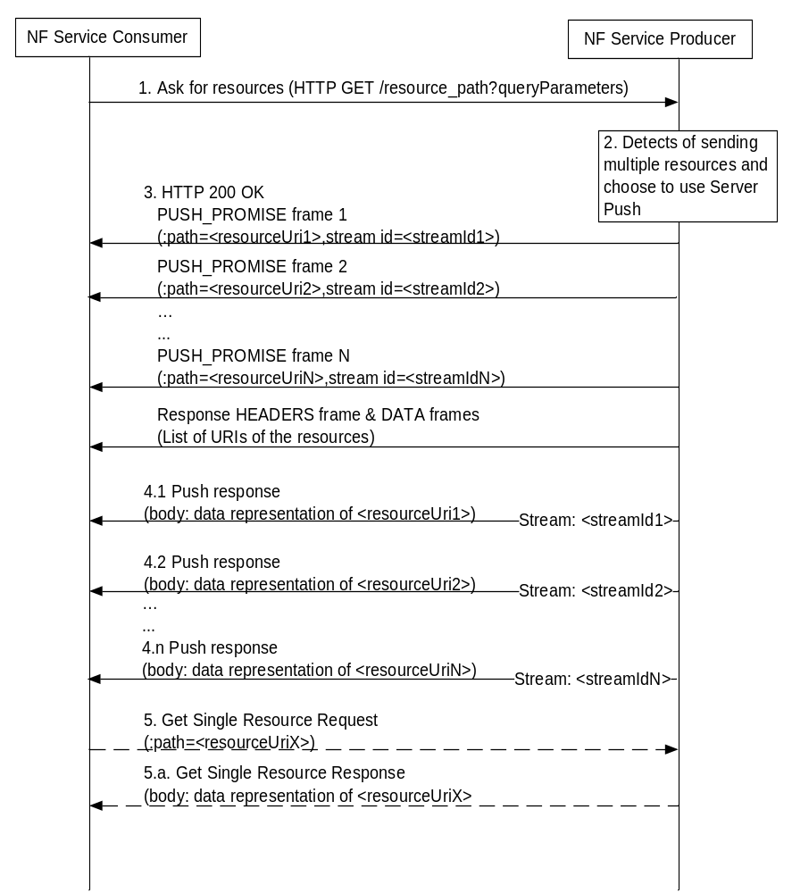
Figure 4.9.5-1 Indirect Delivery with HTTP/2 Server Push
1. A NF Service Consumer sends a HTTP request to get resources(s) to the NF Service Producer, e.g. a query of a collection of resources.
2. The NF Service Producer detects that multiple resources are to be returned and choose to indirectly deliver the resources with the Server Push mechanism.
3. The NF Service Producer returns multiple PUSH_PROMISE Requests before HEADERS frame and DATA frames(s) to the NF Service Consumer. Each PUSH_PROMISE Request contains the URI of one resource to be transferred and the identifier of the reserved stream used for transferring the resource. The NF Service Producer shall also send links with the URIs of the resources in DATA frame(s) of the response message.
4.1-4.n. The NF Service Producer sends Push Reponses via corresponding reserved streams. Each Push Response contains the representation of the associated resource.
5. If the NF Service Consumer does not successfully receive a resource in time, it may send a request to get that resource, using the resource URI previously received from the Push Request.
5.a. The NF Service Producer returns the data of the requested resource in the response.

4.9.6 Criteria for choosing the transfer method
The following considerations may be used to determine which method to use transfer multiple resources to a NF Service Consumer.
If the size of the representation of each resource is small, direct delivery is preferred. If the number of resources to be returned is large, the NF Service Producer may choose iterative delivery.
If the size of the representation of each resource is large, indirect delivery is preferred. If the NF Service Producer supports HTTP/2 Server Push, then:
- when SETTINGS_ENABLE_PUSH parameter with value "1" has been received from the NF Service Consumer, as specified in IETF RFC 7540 [13], it should choose HTTP/2 Server Push to deliver the resource.
- when SETTINGS_ENABLE_PUSH parameter with value "0" has been received from the NF Service Consumer, as specified in IETF RFC 7540 [13], it must not choose HTTP/2 Server Push to deliver the resources.
- when SETTINGS_ENABLE_PUSH parameter has not been received from the NF Service Consumer, as specified in IETF RFC 7540 [13], it may decide whether to use HTTP/2 Server push or not, depending on other factors, e.g. operator policy, whether the client and server pertain to the same PLMN, etc.
Editor's Note: It is FFS on the definition of "small" and "large" of the resource representation size.
Editor's Note: the above considerations are FFS.
Editor's Note: It is FFS whether the NF Service Consumer needs to indicate to the server that server can use server push, to ensure that the server does so only when really required (this is to avoid having the server to "speculate" on what the client may need). The use of the HTTP Server Push may need to be negotiated per API.

5 Documenting 5GC SBI APIs

5.1 Naming Conventions
This clause provides guidelines on naming conventions that should be followed when defining SBI APIs.

5.1.1 Case Conventions
The following case conventions for names and strings are used in the 5GC SBI service APIs.
1) UPPER_WITH_UNDERSCORE
All letters of a string are capital letters. Digits are allowed. Word boundaries are represented by the underscore "_" character. No other characters are allowed.
Example 1:
a) DATA_MANAGEMENT
b) CELL_CHANGE
2) lower_with_underscore
All letters of a string are lowercase letters. Digits are allowed. Word boundaries are represented by the underscore "_" character. No other characters are allowed.
Example 2:
a) data_management;
b) cell_change.
3) UPPER-WITH-HYPHEN
All letters of a string are capital letters. Digits are allowed. Word boundaries are represented by the hyphen "-" character. No other characters are allowed.
Example 3:
a) DATA-MANAGEMENT
b) CELL-CHANGE
4) lower-with-hyphen
All letters of a string are lowercase letters. Digits are allowed. Word boundaries are represented by the hyphen "-" character. No other characters are allowed.
Example 4:
a) data-management;
b) cell-change.
5) UpperCamel
A string is formed by concatenating words. Each word starts with an uppercase letter (this implies that the string starts with an uppercase letter). All other letters are lowercase letters. Digits are allowed. No other characters are allowed. Abbreviations follow the same scheme (i.e. first letter uppercase, all other letters lowercase).
Example 5:
a) DataManagement.
b) CellChange
6) lowerCamel
A string is formed by concatenating words. The first word starts with a lowercase letter, all subsequent words starts with an uppercase letter (this implies that the string starts with an lowercase letter). All other letters are lowercase letters. Digits are allowed. No other characters are allowed. Abbreviations follow the same scheme.
Example 6:
a) dataManagement;
b) cellChange.

5.1.2 API Naming Conventions
An API shall take the name of the corresponding service (e.g. Nudm_SubscriberDataManagement). When used in URIs the name shall be converted to lower-with-hyphen and may use an abbreviated form (e.g. nudm-sdm).

5.1.3 Conventions for URI Parts

5.1.3.1 Introduction
The parts of the URI syntax that are relevant in the context of the 5GC SBI service APIs are as follows:
- Path, consisting of segments, separated by "/" (e.g. segment1/segment2/segment3).
- Query, consisting of pairs of parameter name and value (e.g., ?mcc=262&mnc=01, where two pairs are presented).

5.1.3.2 URI Path Segment Naming Conventions
a) All path segments of a resource URI which represent a string constant shall use lower-with-hyphen (this implies that a path cannot end with "/").
Example 1:
subscriber-data
b) If a resource represents a collection of entities and the last path segment of the resource URI is a string constant, that last path segment shall be plural.
Example 2:
…/prefix/api/v1/users
c) For resources where the last path segment of the resource URI is a string constant, that last path segment shall be a noun or a composite noun.
Example 3:
…/prefix/api/v1/users
Example 4:
…/prefix/api/v1/user-session
d) For custom operations, the last path segment of the URI via which the operation is invoked shall be a verb, or shall start with a verb.
Example 5:
…/app_instances/{appInstanceId}/instantiate
Example 6:
…/sessions/terminate-all
e) All path segments of a URI which are variable names shall use lowerCamel, and shall be surrounded by curly brackets.
Example 7:
…/subscriber-data/{supi}
f) Once a variable is replaced at runtime by an actual string, the string shall follow the rules for a path segment defined in IETF RFC 3986 [9]. IETF RFC 3986 [9] disallows certain characters from use in a path segment. Each actual 5GC SBI service API specification shall define this restriction to be followed when generating values for path segment variables, or propose a suitable encoding (such as percent-encoding according to IETF RFC 3986 [9]), to escape such characters if they can appear in input strings intended to be substituted for a path segment variable.

5.1.3.3 URI Query Naming Conventions
a) URI query parameter names in queries shall use lower-with-hyphen.
Example 1:
?nf-type=AMF
b) Variables that represent actual parameter values in queries shall use lowerCamel and shall be surrounded by curly brackets.
Example 2:
?nf-id={chooseAValue}
c) When a variable is replaced at runtime by an actual string, the convention defined in clause 5.1.3.2 item f) applies to that string.

5.1.4 Conventions for Names in Data Structures
The following syntax conventions apply when defining the names for attributes in the 5GC SBI service API data structures, carried in the payload body of http requests and responses.
a) Names of attributes shall be represented using lowerCamel.
Example 1:
attributeName
b) Names of arrays (i.e. those with cardinality 1..N or 0..N) shall be plural rather than singular.
Example 2:
users
c) Each value of an enumeration type shall be represented using UPPER_WITH_UNDERSCORE.
Example 3:
BLACK_LISTED
d) The names of data types shall be represented using UpperCamel.
Example 4:
ResourceHandle

5.2 API Definition

5.2.1 Resource Structure
Resource structure shall define the structure of the resource URIs, and the resources and methods used for the service. Figure 5.2.1-1 provides an example of the resource URI structure of an API. Table 5.2.1-1 provides an overview of the resources defined for the service and the applicable HTTP methods.
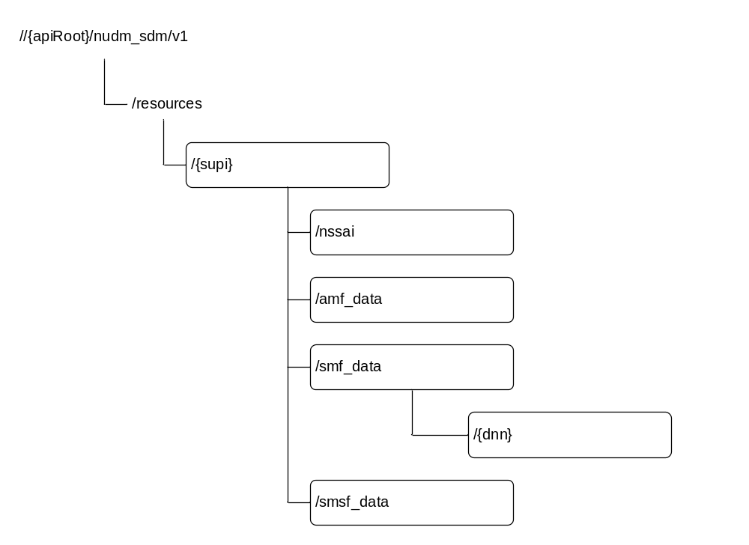
Figure 5.2.1-1: Resource URI structure of the <xyz > API
In the previous figure, a child node with a frame represents a sub-URI that has at least one supported operation associated. All child node names are examples only.
Table 5.2.1-1: Resources and methods overview
Resource name | Resource URI | HTTP method or custom operation | Description
<Resource name> | <relative URI below root> | GET | <Operation executed by GET>
<Resource name> | <relative URI below root> | PUT | <Operation executed by PUT>
<Resource name> | <relative URI below root> | PATCH | <Operation executed by PATCH>
<Resource name> | <relative URI below root> | POST | <Operation executed by POST>
<Resource name> | <relative URI below root> | DELETE | <Operation executed by DELETE>
<Resource name> | <relative URI below root> | release  (POST) | <Operation executed by Custom operation>

5.2.2 Resources and HTTP Methods
Resources and HTTP methods shall specify the resource URI, resource URI variables for the resource and the standard HTTP methods supported by the resource.
Resource URI: {apiRoot}/{apiName}/{apiVersion}/{apiSpecificResourceUriPart}
The resource URI variables supported by the resource shall be defined in Table 5.2.2-1.
Table 5.2.2-1: Resource URI variables for the resource
Name | Definition
< Name of resource URI variables for resource> | < Definition of resource URI variables for resource >

Each method supported by the resource shall be described including the URI query parameters supported by the method, data structures supported by the request body, and the data structures supported by the response body.
URI query parameters supported by the method shall be defined as table 5.2.2-2 illustrates.
Table 5.2.2-2: URI query parameters supported by a method on the resource
Name | Data type | P | Cardinality | Description
<name> or n/a | <type> or <leave empty> | <M, C or O> | 0..1 or 1 or 0..N or 1..N or <leave empty> | <only if applicable>

Name: Name of query parameter in URI. If no query parameter presents for the URI, the name should be marked as "n/a".
Data type: Data type of URI query parameters, i.e. data type defined in specification or leave empty.
P: Presence condition of URI query parameters. It shall be one of "M" (for Mandatory), "C" (for Conditional) and "O" (for Optional).
Cardinality: Defines the allowed number of occurrence. It shall be "0..1", "1", "0..N", "1..N" or leave empty.
Description: Additional information for URI query parameter, i.e. describes the use of the parameter or the presence condition of the parameter and so on.
Data structures supported by the request body of the method shall be specified as table 5.2.2-3 illustrates.
Table 5.2.2-3: Data structures supported by the request body on the resource
Data type | P | Cardinality | Description
"<type>" or "array(<type>)" or "map(<type>)" or n/a | "M", "C" or "O" | "0..1", "1", or "M..N", or <leave empty> | <only if applicable>

Data type: Data type of the data structure in the request body. If the data type is indicated as "<type>", the request body shall be of data type <type>. If the data type is indicated as "array(<type>)", the request body shall be an array (see IETF RFC 8259 [3]) that contains elements of data type <type>. If the data type is indicated as "map(<type>)", the request body shall be an object (see IETF RFC 8259 [3]) encoding a map (see subclause 5.2.4.2) that contains as values elements of data type <type>. <type> can either be "integer", "number", "string" or "boolean" (as defined in the OpenAPI specification [4]), or a data type defined in a 3GPP specification. If no request body is allowed, the Data type shall be marked as "n/a".
P: Presence condition of a data structure in request body. It shall be one of "M" (for Mandatory), "C" (for Conditional) and "O" (for Optional).
Cardinality: Defines the allowed number of occurrence of data type <type>. A cardinality of "M..N", is only allowed for data types "array(<type>)" and "map(<type>)" and indicates the number of elements within the array or map; the values M and N can either be the characters "M" and "N", respectively, or integer numbers with M being greater than or equal 0, and N being greater than 0 and M. For data type "<type>", the cardinality shall be set to "0..1" if the Presence condition is "C" or "O", and to "1" if the Presence condition is "M". The Cardinality shall be left empty if no request body is allowed.
Description: Additional information for a data structure, i.e. describes the use of the data structure or the presence condition of the data structure and so on.
Data structures supported by the response body of the method shall be specified as table 5.2.2-4 illustrated.
Table 5.2.2-4: Data structures supported by the response body on the resource
Data type | P | Cardinality | Response  codes | Description
"<type>" or "array(<type>)" or "map(<type>)" or n/a | "M", "C" or "O" | "0..1", "1", or "M..N", or <leave empty> | <list applicable codes with name from the applicable RFCs> | <Meaning of the success case>  or  <Meaning of the error case with additional statement regarding error handling>

Data type: Data type of the data structure in the response body. If the data type is indicated as "<type>", the response body shall be of data type <type>. If the data type is indicated as "array(<type>)", the response body shall be an array (see IETF RFC 8259 [3]) that contains elements of data type <type>. If the data type is indicated as "map(<type>)", the response body shall be an object (see IETF RFC 8259 [3]) encoding a map (see subclause 5.2.4.2) that contains as values elements of data type <type>. <type> can either be "integer", "number", "string" or "boolean" (as defined in the OpenAPI specification [4]), or a data type defined in a 3GPP specification. If no response body is allowed, the Data type shall be marked as "n/a".
P: Presence condition of a data structure in response body. It shall be one of "M" (for Mandatory), "C" (for Conditional) and "O" (for Optional).
Cardinality: Defines the allowed number of occurrence of data type <type>. A cardinality of "M..N", is only allowed for data types "array(<type>)" and "map(<type>)" and indicates the number of elements within the array or map; the values M and N can either be the characters "M" and "N", respectively, or integer numbers with M being greater than or equal 0, and N being greater than 0 and M. For data type "<type>", the cardinality shall be set to "0..1" if the Presence condition is "C" or "O", and to "1" if the Presence condition is "M". The Cardinality shall be left empty if no response body is allowed.
Response codes: Lists applicable response codes with name from HTTP Status Code Registry at IANA [12]. Mandatory HTTP status codes listed in Table 5.2.7.1-1 of 3GPP TS 29.500 [2] for the corresponding HTTP method shall only be included if specific clarifications in the description part or special data types of the response body are required. Applicable HTTP status codes in addition to the mandatory HTTP status codes listed in Table 5.2.7.1-1 of 3GPP TS 29.500 [2] for the corresponding HTTP method shall be included.
Description: Additional information for a response, i.e. describes the meaning of the success case or meaning of the error case with additional statement regarding error handling.

5.2.3 Representing RPC as Custom Operations on Resources
Custom operations (RPC-style interaction) may be used on a resource. The description of each custom operation contains the custom operation URI, the HTTP method on which the operation is mapped (typically POST), data structures supported by the request body and the data structures supported by the response body.
An overview of the custom operations on a resource is illustrated in table 5.2.3-1.
Table 5.2.3-1: Custom operation
Custom operation URI | Mapped HTTP method | Description
<custom operation URI> | e.g. POST | <Operation executed by custom operation>

Data structures supported by the request body of the method shall be specified as table 5.2.3-2 illustrates.
Table 5.2.3-2: Data structures supported by the mapped HTTP method request body on the resource
Data type | P | Cardinality | Description
"<type>" or "array(<type>)" or "map(<type>)" | "M", "C" or "O" | "0..1", "1", or "M..N", or <leave empty> | <only if applicable>

Data type: Data type of the data structure in the request body. If the data type is indicated as "<type>", the request body shall be of data type <type>. If the data type is indicated as "array(<type>)", the request body shall be an array (see IETF RFC 8259 [3]) that contains elements of data type <type>. If the data type is indicated as "map(<type>)", the request body shall be an object (see IETF RFC 8259 [3]) encoding a map (see subclause 5.2.4.2) that contains as values elements of data type <type>. <type> can either be "integer", "number", "string" or "boolean" (as defined in the OpenAPI specification [4]), or a data type defined in a 3GPP specification. If no request body is allowed, the Data type shall be marked as "n/a".
P: Presence condition of a data structure in request body. It shall be one of "M" (for Mandatory), "C" (for Conditional) and "O" (for Optional).
Cardinality: Defines the allowed number of occurrence of data type <type>. A cardinality of "M..N", is only allowed for data types "array(<type>)" and "map(<type>)" and indicates the number of elements within the array or map; the values M and N can either be the characters "M" and "N", respectively, or integer numbers with M being greater than or equal 0, and N being greater than 0 and M. For data type "<type>", the cardinality shall be set to "0..1" if the Presence condition is "C" or "O", and to "1" if the Presence condition is "M". The Cardinality shall be left empty if no request body is allowed.
Description: Additional information for a data structure, i.e. describes the use of the data structure or the presence condition of the data structure and so on.
Data structures supported by the response body of the method shall be specified as table 5.2.3-3 illustrates.
Table 5.2.3-3: Data structures supported by the mapped HTTP method response body on the resource
Data type | P | Cardinality | Response  codes | Description
"<type>" or "array(<type>)" or "map(<type>)" | "M", "C" or "O" | "0..1", "1" or "M..N", or <leave empty> | <list applicable codes with name from the applicable RFCs> | <Meaning of the success case>  or  <Meaning of the error case with additional statement regarding error handling>

Data type: Data type of the data structure in the response body. If the data type is indicated as "<type>", the response body shall be of data type <type>. If the data type is indicated as "array(<type>)", the response body shall be an array (see IETF RFC 8259 [3]) that contains elements of data type <type>. If the data type is indicated as "map(<type>)", the response body shall be an object (see IETF RFC 8259 [3]) encoding a map (see subclause 5.2.4.2) that contains as values elements of data type <type>. <type> can either be "integer", "number", "string" or "boolean" (as defined in the OpenAPI specification [4]), or a data type defined in a 3GPP specification. If no response body is allowed, the Data type shall be marked as "n/a".
P: Presence condition of a data structure in response body. It shall be one of "M" (for Mandatory), "C" (for Conditional) and "O" (for Optional).
Cardinality: Defines the allowed number of occurrence of data type <type>. A cardinality of "M..N", is only allowed for data types "array(<type>)" and "map(<type>)" and indicates the number of elements within the array or map; the values M and N can either be the characters "M" and "N", respectively, or integer numbers with M being greater than or equal 0, and N being greater than 0 and M. For data type "<type>", the cardinality shall be set to "0..1" if the Presence condition is "C" or "O", and to "1" if the Presence condition is "M". The Cardinality shall be left empty if no response body is allowed.
Response codes: Lists applicable response codes with name from HTTP Status Code Registry at IANA [12]. Mandatory HTTP status codes listed in Table 5.2.7.1-1 of 3GPP TS 29.500 [2] for the corresponding HTTP method shall only be included if specific clarifications in the description part or special data types of the response body are required. Applicable HTTP status codes in addition to the mandatory HTTP status codes listed in Table 5.2.7.1-1 of 3GPP TS 29.500 [2] for the corresponding HTTP method shall be included.
Description: Additional information for a response, i.e. describes the meaning of the success case or meaning of the error case with additional statement regarding error handling.

5.2.4 Data Models

5.2.4.1 General
The application data model supported by the API shall be specified with the following data types:
1. Structured data types
2. Simple data types
3. Enumerations
4. Binary data
5. Data types describing alternative data types
6. Data types describing combinations of data types
Each data type can be specific for the API or common to multiple APIs (offered by the same or different NFs). The common data types shall be specified in 3GPP TS 29.571 [5].

5.2.4.2 Structured data types
The structured data types shall represent an object (see IETF RFC 8259 [3]). The structured data types shall contain attributes that are simple data types, structured data types, arrays (see below), maps (as defined below), enumerations, data types describing alternative data types, or data types describing combinations of data types.
An array (see IETF RFC 8259 [3]) shall represent a list of values without keys and with significance in the order of sequence. All values shall be of the same type.
A map shall represent an object (see IETF RFC 8259 [3]) with a list of key-value pairs (with no significance in the order of sequence), where all keys are of type string and shall be unique identifiers assigned by the application rather than by the schema, and where all values shall be of the same type.
NOTE 1: Maps are supported by the OpenAPI specification [4] as described at https://swagger.io/docs/specification/data-models/dictionaries/. Maps can enable a faster lookup of elements identified by some key in huge data structures compared to arrays that contain the key within the elements. Maps can also be used instead of arrays to modify individual elements when modification instructions of the PATCH method are compliant to IETF RFC 7396 [7].
Each structured data type shall be specified in a separate subclause as illustrated in table 5.2.4.2-1.
Table 5.2.4.2-1: Definition of type <Data type>
Attribute name | Data type | P | Cardinality | Description | Applicability
<attribute name> | "<type>" or "array(<type>)" or "map(<type>)" | "M", "C" or "O" | "0..1", "1" or "M..N" | <only if applicable>

Attribute name: Name of attributes that belong to the specified data type. The attribute names within a structured data type shall be unique, and their relative order inside the structured data type shall not imply any specific ordering of the corresponding JSON elements in a JSON object.
NOTE 2: The JSON specification (IETF RFC 8259 [3]) allows duplicate keys in a JSON object, but its usage is discouraged, since it makes interoperability more difficult, and makes the behavior of the JSON parsing software unpredictable. Similarly, that RFC encourages to make implementations not dependent on attribute ordering.
Data type: Data type of the attribute. If the data type is indicated as "<type>", the attribute shall be of data type <type>. If the data type is indicated as "array(<type>)", the attribute shall be an array (see IETF RFC 8259 [3]) that contains elements of data type <type>. If the data type is indicated as "map(<type>)", the attribute shall be an object (see IETF RFC 8259 [3]) encoding a map that contains as values elements of data type <type>. <type> can either be "integer", "number", "string" or "boolean" (as defined in the OpenAPI specification [4]), or a data type defined in a 3GPP specification.
P: Presence condition of a data structure in request body. It shall be one of "M" (for Mandatory), "C" (for Conditional) and "O" (for Optional).
Cardinality: Defines the allowed number of occurrence of data type <type>. A cardinality of "M..N", is only allowed for data types "array(<type>)" and "map(<type>)" and indicates the number of elements within the array or map; the values M and N can either be the characters "M" and "N", respectively, or integer numbers; with M being greater than or equal 0, and N being greater than 0 and M. For data type "<type>", the cardinality shall be set to "0..1" if the Presence condition is "C" or "O", and to "1" if the Presence condition is "M".
Description: Describes the meaning and use of the attribute and may contain normative statements.
Applicability: If the attribute is only applicable for optional feature(s) negotiated using the mechanism defined in subclause 6.6 of 3GPP TS 29.500 [2], the name of the corresponding feature(s) shall be indicated in this column. If no feature is indicated. the attribute can be used with any feature.
NOTE 3: If no optional features are defined for an API, the applicability column can be omitted for that API.

5.2.4.3 Simple data types and enumerations
The simple data types and enumerations can be referenced from data structures. All simple data types and enumerations should map to base types supported by IDL. Simple data types shall be specified as illustrated in table 5.2.4.3-1.
Table 5.2.4.3-1: Simple data types
Type Name | Type Definition | Description | Applicability
 | <one simple data type, i.e. boolean, integer, number, or string>

Type Name: The name of the simple data type.
Type Definition: Base types supported by IDL, i.e. Boolean, integer, string and so on.
Description: Additional descriptions for simple data types like range, string length and so on.
Applicability: If the type is only applicable for optional feature(s) negotiated using the mechanism defined in subclause 6.6 of 3GPP TS 29.500 [2], the name of the corresponding feature(s) shall be indicated in this column. If no feature is indicated. the type can be used with any feature.
NOTE 1: If no optional features are defined for an API, the applicability column can be omitted for that API.

Each enumeration type shall be respectively specified for their elements sets as illustrated in table 5.2.4.3-2.
Table 5.2.4.3-2: Enumeration < EnumType>
Enumeration value | Description | Applicability
Enumeration value 1 | The description of this enum value
Enumeration value 2 | The description of this other enum value

Enumeration value: Defines the valid values, which can be integer, string or boolean, it is suggested to keep the same value style in one API specification.
Description: Additional descriptions for enumeration attributes, like the meaning and usage of enumeration elements.
Applicability: If the enumeration value is only applicable for optional feature(s) negotiated using the mechanism defined in subclause 6.6 of 3GPP TS 29.500 [2], the name of the corresponding feature(s) shall be indicated in this column. If no feature is indicated. the enumeration value can be used with any feature.
NOTE 2: If no optional features are defined for an API, the applicability column can be omitted for that API.

5.2.4.4 Binary Data

5.2.4.5 Data types describing alternative data types or combinations of data types
The data types describing alternative data types or combinations of data types shall represent an OpenAPI schema object using the "oneOf" , "anyOf" or "allOf" keyword to list alternative or to be combined data types (see the OpenAPI specification [4] and https://swagger.io/docs/specification/data-models/oneof-anyof-allof-not/).
An instance (i.e. a corresponding part of a JSON file to be evaluated against the schema) matches a list of mutually exclusive alternative data types , as described using the OpenAPI "oneOf" keyword, if the instance matches against one and only one of the alternative data types.
NOTE 1: Data types with the same simple data type but different format and/or pattern attributes are mutually exclusive if the corresponding formats and/or patterns are mutually exclusive.
An instance (i.e. a corresponding part of a JSON file to be evaluated against the schema) matches a list of non-exclusive alternative data types, as described using the OpenAPI "anyOf" keyword, if the instance matches against one or more of the alternative data types.
An instance (i.e. a corresponding part of a JSON file to be evaluated against the schema) matches a list of to be combined data types, as described using the OpenAPI "allOf" keyword, if the instance matches against all of the to be combined data types.
The alternative or to be combined data types shall be simple data types, structured data types, arrays (see subclause 5.2.4.2), maps (see subclause 5.2.4.2), enumerations, data types describing alternative data types, or data types describing combinations of data types.
Each structured data type shall be specified in a separate subclause as illustrated in table 5.2.4.2-1.
Table 5.2.4.2-1: Definition of type <Data type> as a list of <"mutually exclusive alternatives" / "non-exclusive alternatives" / "to be combined data types">
Data type | Cardinality | Description | Applicability
"<type>" or "array(<type>)" or "map(<type>)" | "1" or "M..N" | <only if applicable>

Data type: Data type of the alternative or to be combined data type. If the data type is indicated as "<type>", the alternative or to be combined data type shall be of data type <type>. If the data type is indicated as "array(<type>)", the alternative or to be combined data type shall be an array (see IETF RFC 8259 [3]) that contains elements of data type <type>. If the data type is indicated as "map(<type>)", the alternative or to be combined data type shall be an object (see IETF RFC 8259 [3]) encoding a map (see subclause 5.2.4.2) that contains as values elements of data type <type>. <type> can either be "integer", "number", "string" or "boolean" (as defined in the OpenAPI specification [4]), or a data type defined in a 3GPP specification.
Cardinality: Defines the allowed number of occurrence of data type <type>. A cardinality of "M..N", is only allowed for data types "array(<type>)" and "map(<type>)" and indicates the number of elements within the array or map; the values M and N can either be the characters "M" and "N", respectively, or integer numbers; with M being greater than or equal 0, and N being greater than 0. For data type "<type>", the cardinality shall be set to "1".
Description: Describes the meaning and use of the attribute and may contain normative statements.
Applicability: If the type is only applicable for optional feature(s) negotiated using the mechanism defined in subclause 6.6 of 3GPP TS 29.500 [2], the name of the corresponding feature(s) shall be indicated in this column. If no feature is indicated. the type can be used with any feature.
NOTE 2: If no optional features are defined for an API, the applicability column can be omitted for that API.
NOTE 3: Data types describing alternative data types or combinations of data types can only be extended with additional data types in a backward compatible manner if the new data types are associated with an optional feature and the mechanism defined in subclause 6.6 of 3GPP TS 29.500 [2] is used to negotiate the support of that optional feature before that new data type is used.

5.2.5 Relation types
This clause provides the list of relation types supported by the API. It is needed only if the API implements HATEOAS.

5.3 Open API specification files

5.3.1 General
5GC SBI APIs' Open API specification files shall comply with the OpenAPI specification [4] and with the present subclause 5.3.
Each API shall be described in one Open API specification file. In addition, 3GPP specifications may contain Open API specification file with common data types.
For the purpose of referencing (see subclause 5.3.6), it is assumed that each Open API specification file contained in a 3GPP specification is stored as separate physical, that all Open API specification files are stored in the same directory on the local server, and that the files are named according to the conventions in subclause 5.3.6.

5.3.2 Formatting of OpenAPI files
The following guidelines shall be used when documenting OpenAPI files:
- OpenAPI specifications shall be documented using YAML format (see YAML 1.2 [16]). For specific restrictions on the usage of YAML in OpenAPI, see OpenAPI 3.0.0 Specification [4].
- The style used for the specification shall be "PL" (Programming Language).
- The different scopes in the YAML data structures representing collections (objects, arrays…) shall use an indentation of two white spaces.
- Comments may be added by following the standard YAML syntax ("#").

5.3.3 Info
The Open API specification file of an API shall contain an "info" field with the title set to the same value as chosen for the corresponding base URL parts (see subclause 4.4) of that API and with the version set as described in subclause 4.3.
Example:
info:
title: Nxxx_Yyy
version: 1.R15.0.0

5.3.4 externalDocs
Each OpenAPI specification shall provide in an "externalDoc" field the reference to only one 3GPP TS describing the API, including the version number, as illustrated below.
Example:
externalDocs
description: 3GPP TS Unified Data Management Services version 15.0.0
url: http://www.3gpp.org/ftp/Specs/archive/29_series/29.503/29503-g00.zip
…

5.3.5 Servers
As defined in subclause 4.4, the base URI of an API consists of {apiRoot}/{apiName}/{apiVersion}. It shall be encoded in the corresponding Open API specification file as "servers" field with {apiRoot} as variable.
Example:
servers:
- url: https://{apiRoot}/Nxxx_Yyyy/v1
variables:
apiRoot:
default: https://demohost.com
description: apiRoot as defined in subclause subclause 4.4 of 3GPP TS 29.501, excluding the https:// part.

5.3.6 References to other 3GPP-defined Open API specification files
For the purpose of referencing, it shall be assumed that each Open API specification file contained in a 3GPP specification is stored as separate physical file, that all Open API specification files are stored in the same directory on the local server, and that the files are named according to the following convention: The file name shall consist of (in the order below):
- the 3GPP specification number in the format "TSxxyyy";
- an "_" character;
- if the OpenAPI specification file contains an API definition, the API name as defined for corresponding base URL parts (see subclause 4.4) of that API.
- if the OpenAPI specification file contains a definition of CommonData, the string "CommonData"; and
- the string ".yaml".

Examples:
Reference to Data Type "Xxx" defined in the same file
$ref: '#/components/schemas/Xxx'

Reference to Data Type "Xxx" defined as Common Data in 3GPP TS 29.571:
$ref: 'TS29571_CommonData.yaml#/components/schemas/Xxx'

Reference to Data Type "Xxx" defined within API "Nxxx_Yyy" in 3GPP "TS ab.cde":
$ref: 'TSabcde_Nxxx_Yyy.yaml#/components/schemas/Xxx'

5.3.7 Server-initiated communication
If an API contains server-initiated communication (see subclause 6.2 of 3GPP TS 29.500 [2]), e.g. for notifications as described in subclause 4.6.2.3, it should be described as "callbacks" in Open API specification files.
Example:
paths:
/subscriptions:
post:
requestBody:
required: true
content:
application/json:
schema:
type: object
properties:
callbackUrl: # Callback URL
type: string
format: uri
responses:
'201':
description: Success
callbacks:
myNotification: # arbitrary name
'{$request.body#/callbackUrl}': # refers The callback URL in the POST
post:
requestBody: # Contents of the callback message
required: true
content:
application/json:
schema:
$ref: '#/components/schemas/NotificationBody'
responses: # Expected responses to the callback message
'200':
description: xxx

5.3.8 Describing the body of HTTP PATCH requests

5.3.8.1 General
As described in subclause 4.6.1.1.3.2, the bodies of HTTP PATCH requests either use a "JSON Merge Patch" encoding as defined in IETF RFC 7396 [7], or a "JSON Patch" encoding as defined IETF RFC 6902 [8].
It is possible to allow both encodings in a OpenAPI Specification [4] offering both schemas as alternative contents.
NOTE: In Rel-15 a single encoding will be selected for each resource as backward compatibility considerations do not yet apply.
An example OpenAPI file offering both PATCH encodings is included in Annex D.

5.3.8.2 JSON Merge Patch
In the OpenAPI Specification [4] file, the content field key of the Request Body Object shall contain "application/merge-patch+json". The content field value is a Media Type Object identifying the applicable patch body Schema Object. The patch body Schema Object may contain structured data types derived from the data types used in the schema to describe a complete representation of the resource in such a manner that attributes that are allowed to be modified are listed in the "properties" validation keyword.
NOTE 1: A derived structured data type is beneficial if the data types used to describe a complete representation of the resource contains mandatory attributes, if attributes are allowed to be removed by the PATCH operation, or if a checking by the OpenAPI tooling that only allowed modifications are done via the "additionalProperties: false" keyword is desired. It also provides a clear description in the OpenAPI file to developers which modifications need to be supported.
As an alternative, the data types used in the schema to describe a complete representation of the resource may be used if any attributes that are allowed to be removed are marked as "nullable: true" in that schema.
Any attributes that are allowed to be removed shall be marked as "nullable: true" in the patch body Schema Object.
The "additionalProperties: false" keyword may be set.
NOTE 2: The "additionalProperties: false" keyword enables the OpenAPI tooling to check that only allowed modifications are done. Extensions of the object in future releases are still possible under the assumption that the supported features mechanism is used to negotiate the usage of any new attribute prior to the PATCH invocation. If new optional attributes are expected to be introduced without corresponding supported feature or if PATCH can be used as first operation in an API, the usage of the "additionalProperties: false" keyword is not appropriate.

5.3.8.3 JSON PATCH
In the OpenAPI Specification [4] file, the content field of the key Request Body Object shall contain "application/json-patch+json". The content field value is a Media Type Object identifying the applicable patch body. It may contain a mutually exclusive list (using the "oneOf" keyword) of all allowed modifications as <path, op, value> tuples, where “path” is a string containing a JSON Pointer value referring to a JSON object that is allowed to be modified, “op” is an enumeration of allowed JSON PATCH operations on the JSON object identified by “path” and “value” representing the schema/type of the value that will be updated or added at the JSON object identified by “path”. In addition, an open alternative containing an object with no properties may be added using the "anyOf" keyword.
NOTE 1: A mutually exclusive list provides a clear description in the OpenAPI file to developers which modifications need to be supported. This is of particular interest if only a limited number of modifications need to be supported. If no open alternative is included, the OpenAPI tooling will also check that only allowed modifications are done.
NOTE 2: The open alternative allows for extensions of the PATCH in scenarios where new optional attributes are expected to be introduced without corresponding supported feature or if PATCH can be used as first operation in an API.

5.3.9 Structured data types
For a structured data type, as defined in subclause 5.2.4.2, the OpenAPI specification [4] file shall contain a definition in the components/schemas section defining a schema with the name of the structured data type as key.
The schema shall contain:
- "type: object";
- if any attributes in the structured data type are marked as mandatory, a "required" keyword listing those attributes; and
- a "properties" keyword containing for each attribute in the structured data type an entry with the attribute name as key and:
1. if the data type is "<type>":
a. if the data type of the attribute is "string", "number", "integer", or "boolean";
i) a type definition using that data type as value ("type: <data type>"); and
ii) optionally "description: <description>", where <description> is the description of the attribute in the table defining the structured data type; or
b. otherwise a reference to the data type schema for the data type <data type> of the attribute, i.e. "$ref: '#/components/schemas/<data type>'" if that data type schema is contained in the same OpenAPI specification file and "$ref: '<filename>#/components/schemas/<data type>'" if that data type schema is contained in file <filename> in the same directory on the same server;
2. if the data type is "array(<type>)":
a. a type definition "type: array";
b. an "items:" definition containing:
i). if the data type of the attribute is "string", "number", "integer", or "boolean", a type definition using that data type as value ("type: <data type>"); or
ii). otherwise a reference to the data type schema for the data type <data type> of the attribute, i.e. "$ref: '#/components/schemas/<data type>'" if that data type schema is contained in the same OpenAPI specification file and "$ref: '<filename>#/components/schemas/<data type>'" if that data type schema is contained in file <filename> in the same directory on the same server;
c. if the cardinality contained an integer value <m> as lower boundary, "minItems: <m>"; and
d. if the cardinality contained an integer value <n> as upper boundary, "maxItems: <n>"; and
e. optionally "description: <description>", where <description> is the description of the attribute in the table defining the structured data type;
3. if the data type is "map(<type>)":
a. a type definition "type: object"; and
b. an "additionalProperties:" definition containing:
i). if the data type of the attribute is "string", "number", "integer", or "boolean", a type definition using that data type as value ("type: <data type>"); or
ii). otherwise a reference to the data type schema for the data type <data type> of the attribute, i.e. "$ref: '#/components/schemas/<data type>'" if that data type schema is contained in the same OpenAPI specification file and "$ref: '<filename>#/components/schemas/<data type>'" if that data type schema is contained in file <filename> in the same directory on the same server;
c. if the cardinality contained an integer value <m> as lower boundary, "minProperties: <m>"; and
d. if the cardinality contained an integer value <n> as upper boundary, "maxProperties: <n>"; and
e. "description: <description>", where <description> is the description of the attribute in the table defining the structured data type.
NOTE: An omission of the "minProperties", and "maxProperties" keywords indicates that no lower or upper boundaries respectively, for the number of properties in an object are defined. An omission of the "minItems", and "maxItems" keywords indicates that no lower or upper boundaries, respectively, for the number of items in an array are defined.
Example:
Table 5.3.9-1: Definition of type ExampleStructuredType
Attribute name | Data type | P | Cardinality | Description | Applicability
exSimple | ExSimple | M | 1 | exSimple attribute description
exArrayElements | array(string) | O | 0..10 | exArrayElements attribute description
exMapElements | map(ExStructure) | M | 1..N | exMapElements attribute description

The data structure in table 5.3.9-1 is described in an OpenAPI specification file as follows:
components:
schemas:
ExampleStructuredType:
type: object
required:
- exSimple
- exMapElements
properties:
exSimple:
$ref: '#/components/schemas/ExSimple'
exArrayElements:
type: array
items:
type: string
minItems: 0
maxItems: 10
description: exArrayElements attribute description
exMapElements:
type: object
additionalProperties:
$ref: '#/components/schemas/ExStructure'
minProperties: 1
description: exMapElements attribute description

5.3.10 Data types describing alternative data types or combinations of data types
For a data type describing alternatives, as defined in subclause 5.2.4.5, the OpenAPI specification [4] file shall contain a definition in the components/schemas section defining a schema with the name of the data type describing alternatives as key.
The schema shall contain:
- the "oneOf", "anyOf" or "allOf" keyword selected as follows:
1. for table caption "Definition of type <Data type> as a list of mutually exclusive alternatives", the "oneOf" keyword;
2. for table caption "Definition of type <Data type> as a list of non-exclusive alternatives", the "anyOf" keyword;
3. for table caption "Definition of type <Data type> as a list of to be combined data types", the "allOf" keyword;
- a list of alternatives, containing for each line in the table describing the data type a separate line starting with "-":
1. if the data type is "<type>":
a. if the data type of the attribute is "string", "number", "integer", or "boolean";
i) a type definition using that data type as value ("type: <data type>"); and
ii) optionally "description: <description>", where <description> is the description of the attribute in the table defining the structured data type; or
b. otherwise a reference to the data type schema for the data type <data type> of the attribute, i.e. "$ref: '#/components/schemas/<data type>'" if that data type schema is contained in the same OpenAPI specification file and "$ref: '<filename>#/components/schemas/<data type>'" if that data type schema is contained in file <filename> in the same directory on the same server;
2. if the data type is "array(<type>)":
a. a type definition "type: array";
b. an "items:" definition containing:
i). if the data type of the attribute is "string", "number", "integer", or "boolean", a type definition using that data type as value ("type: <data type>"); or
ii). otherwise a reference to the data type schema for the data type <data type> of the attribute, i.e. "$ref: '#/components/schemas/<data type>'" if that data type schema is contained in the same OpenAPI specification file and "$ref: '<filename>#/components/schemas/<data type>'" if that data type schema is contained in file <filename> in the same directory on the same server;
c. if the cardinality contained an integer value <m> as lower boundary, "minItems: <m>"; and
d. if the cardinality contained an integer value <n> as upper boundary, "maxItems: <n>"; and
e. optionally "description: <description>", where <description> is the description of the attribute in the table defining the structured data type;
3. if the data type is "map(<type>)":
a. a type definition "type: object"; and
b. an "additionalProperties:" definition containing:
i). if the data type of the attribute is "string", "number", "integer", or "boolean", a type definition using that data type as value ("type: <data type>"); or
ii). otherwise a reference to the data type schema for the data type <data type> of the attribute, i.e. "$ref: '#/components/schemas/<data type>'" if that data type schema is contained in the same OpenAPI specification file and "$ref: '<filename>#/components/schemas/<data type>'" if that data type schema is contained in file <filename> in the same directory on the same server;
c. if the cardinality contained an integer value <m> as lower boundary, "minProperties: <m>"; and
d. if the cardinality contained an integer value <n> as upper boundary, "maxProperties: <n>"; and
e. optionally "description: <description>", where <description> is the description of the attribute in the table defining the structured data type.
NOTE: An omission of the "minProperties", and "maxProperties" keywords indicates that no lower or upper boundaries respectively, for the number of properties in an object are defined. An omission of the "minItems", and "maxItems" keywords indicates that no lower or upper boundaries, respectively, for the number of items in an array are defined.
Example:
Table 5.3.10-1: Definition of type ExampleAlternativesType as a list of mutually exclusive alternatives
Data type | Cardinality | Description | Applicability
ExSimple | 1 | exSimple attribute description
array(string) | 0..10 | exArrayElements attribute description
map(ExStructure) | 1..N | exMapElements attribute description

The data structure in table 5.3.10-1 is described in an OpenAPI specification file as follows:
components:
schemas:
ExampleAlternativesType:
oneOf:
- $ref: '#/components/schemas/ExSimple'
- type: array
items:
type: string
minItems: 0
maxItems: 10
description: exArrayElements attribute description
- type: object
additionalProperties:
$ref: '#/components/schemas/ExStructure'
minProperties: 1
description: exMapElements attribute description

5.3.11 Error Responses
As described in subclause 4.8 of the present specification and subclause 5.2.7 of 3GPP TS 29.500 [2], 5GC SBI APIs use valid HTTP response codes as error codes in HTTP responses and may include a "ProblemDetails" data structure specified in subclause 5.2.4.1 of 3GPP TS 29.571 [5] or an application-specific data structure.
Table 5.2.7.1-1 of 3GPP TS 29.500 [2] specifies HTTP status code per HTTP method. For each HTTP method of an API, HTTP status codes shall be specified using response code tables as described in subclauses 5.2.2 and 5.2.3. OpenAPI files shall include in the description of an HTTP method in the "paths" segment the mandatory HTTP status codes in Table 5.2.7.1-1 of 3GPP TS 29.500 [2] and the HTTP status codes listed in response codes table of that HTTP method.
For the purpose of referencing, HTTP error responses with "ProblemDetails" data structure are specified as part of the CommonData OpenAPI file in Annex A of 3GPP TS 29.571 [5].
Example:
In the example below, the 400, 500 and default error response descriptions defined in 3GPP TS 29.571 [5] are referenced.

paths:
/users:
get:
responses:
'200':
content:
application/json
schema:
$ref: '#/components/schemas/ExampleGetBody'
'400':
$ref: 'TS29571_CommonData.yaml#/components/responses/400'
'500':
$ref: 'TS29571_CommonData.yaml#/components/responses/500'
default:
$ref: 'TS29571_CommonData.yaml#/components/responses/default'

The following definitions provided in Annex A of 3GPP TS 29.571 [5] are used in that example:
components:
responses:
'400':
description: Bad request
content:
application/problem+json:
schema:
$ref: '#/components/schemas/ProblemDetails'
'500':
description: Internal Server Error
content:
application/problem+json:
schema:
$ref: '#/components/schemas/ProblemDetails'
default:
description: Generic Error

5.3.12 Enumerations
For enumerations, as defined in subclause 5.2.4.3, the OpenAPI specification [4] file shall contain a definition in the components/schemas section defining a schema with the name of the enumeration as key.
The schema
- shall contain the "anyOf" keyword listing as alternatives:
1. the "type: string" keyword and the "enum" keyword with a list of all defined values for the enumeration; and
2. the "type: string" keyword and the "description" keyword with a description stating that the string is only provided for extensibility and is not used to encode contents defined in the present version of the specification. and
- may contain a description listing the defined values of the enumeration together with explanations of those values.
NOTE: The "enum" keyword restricts the permissible values of the string to the enumerated ones. This can lead to extensibility problems when new values need to be introduced.
Example:
Table 5.3.12-1: Enumeration ExampleEnumeration
Enumeration value | Description | Applicability
One | Value One description
Two | Value Two description

The data structure in table 5.3.12-1 is described in an OpenAPI specification file as follows:
components:
schemas:
ExampleEnumeration:
anyOf:
- type: string
enum:
- One
- Two
- type: string
description: >
This string provides forward-compatibility with future
extensions to the enumeration but is not used to encode
content defined in the present version of this API.
description: >
Possible values are
- One: Value One description
- Two: Value Two description

Annex A (informative):
TS Skeleton Template
A TS Skeleton Template to be used as a starting point of drafting a 5G System SBI Stage 3 specification is attached to the present TS.

Annex B (informative):
Backward Incompatible Changes
Backward compatible changes are additions or changes in the API that do not break the existing Service Consumer behaviour. Examples of backward compatible changes include:
- Adding a new, optional child resource/URI;
- Supporting a new HTTP method;
- Adding new elements to a resource representation;
- Changing the order of fields in a resource representation.
Backward incompatible changes are additions or changes in the API that break the existing Service Consumer behaviour. Here is a list of backward incompatible changes that shall require incrementing the 1st field (MAJOR) of the API version number:
- Removing a resource/URI:
- Removing support for an HTTP method;
- Renaming a field in a resource representation;
- Adding mandatory parameters to a resource URI or resource representation;
- Attribute data type changes;
- Cardinality changes (NOTE).
NOTE: Whether attribute cardinality changes are backward compatible depend on the type of change. Examples of non-backward compatibility changes include decreasing the upper bound of a cardinality range for attributes sent by the NF service consumer, changing the meaning of the default behavior associated to the absence of an attribute of cardinality 0..N, etc.
Editor’s note: It is for further study whether the addition of a new error code can be considered a backward compatible change.
Editor's note: it is to decide how to use this list. This list can be maintained up-to-date with changes considered as incompatible by 3GPP.

Annex C (Informative):
Resource modelling
When designing an API, one shall first think of defining the set of resources consumed. Resources represent objects that are modified by standard HTTP methods and that can be modelled with one of 4 archetypes detailed below. Resource archetypes help API designers to structure the resources. In this process the designer should refer to the appropriate archetype when the resource definition perfectly matches the archetype one. Referring to an archetype immediately defines what operations and HTTP methods are supported by the resource.
The archetypes provided hereafter don’t preclude the existence of resources of different types.

C.1 Document
The document archetype is the conceptual base archetype of the other ones. Any resource that is not identified with one of the other resource archetypes is a document.
A document may have child resources that represent its specific subordinate concepts.
The archetype does not place any restriction on HTTP methods when acting on a document.
Only CRUD operations are performed directly on a document resource, i.e. by sending an HTTP request to the URI of that resource. Custom methods are not performed directly on the resource, but by sending an HTTP request to a URI that is associated by a convention (see clause X.4) with the URI of the resource.
Editor’s note: The exact operations, methods and definition of the document archetype are FFS.

C.2 Collection
The collection archetype can be used to model a resource that serves as a directory of resources. A collection is NF Service Provider-managed so the NF Service Provider decides the URIs of each resource that is created in the collection.
NOTE: Even though a collection resource typically contains child resources, it is allowed that a particular collection resource does not contain any child resource at a particular point in time ("empty collection").
The Create and Read operations are performed on a collection directly.
More specifically:
- A collection child resource is created by sending a POST with the collection URI if accepted by the collection;
- A collection is read by sending a GET with the collection URI;
- The PUT and PATCH methods with the collection URI are not allowed;
- The DELETE method with the collection URI is only allowed if the collection resource has been created dynamically based on a request from the NF Service Consumer.
- The authorized operations on a collection child resource depend on that resource’s archetype.
Editor’s note: The exact operations, methods and definition of the collection archetype are FFS.

C.3 Store
The store archetype can also be used to model a resource that serves as a directory of resources but a store is NF Service Consumer-managed. The NF Service Consumer solely decides what resource shall be added to / deleted from a store. The NF Service Consumer decides what the URI of the added resource is.
NOTE: Even though a store resource typically contains child resources, it is allowed that a particular store resource does not contain any child resource at a particular point in time ("empty store").
The Read operation is performed on a store directly, and the Create operation is performed on store child resources.
More specifically:
- A store child resource is created by sending a PUT with the URI of the child resource to be created.
- A store is read by sending a GET with the store URI;
- The POST, PUT and PATCH methods with the store URI are not allowed;
- The DELETE method with the store URI is only allowed if the store resource has been created dynamically based on a request from the NF Service Consumer.
- Apart from Create (PUT), the authorized operations on a store child resource depend on that resource’s archetype.
Editor’s note: The exact operations, methods and definition of the store archetype are FFS.

C.4 Custom operation
The custom operation archetype can be used to model an unsafe and non-idempotent operation that is not a Create on a collection.
A custom operation does not operate directly on the resource that would be identified by the custom operation URI. Instead, when the custom operation is associated with a resource, the operation is performed on this associated resource. For instance, a custom operation may modify the associated resource in a special way. This associated resource is identified by stripping the suffix string "/{custOpName}" from the custom operation URI template in clause 4.4.2.
When the custom operation is not associated with any resource but with the service, it acts as an executable function with input parameters and returns the result of the executed function in the response body, not modifying any resource.
POST is the only method allowed with a custom operation URI.
The semantic of the custom operation is encoded in the last segment of the URI template in chapter 4.4.2: /{custOpName}.

Annex D (informative):
Open API example file for Patch
As described in subclause 4.6.1.1.3.2, the bodies of HTTP PATCH requests will either use a "JSON Merge Patch" encoding as defined in IETF RFC 7396 [7], or a "JSON Patch" encoding as defined IETF RFC 6902 [8]. This annex provides an example OpenAPI Specification [4] allowing both encodings.
NOTE: Both encoding possibilities are shown in this example for illustrative purposes. However, only a single of the above encodings will be specified for each resource where the PATCH method is supported unless backward compatibility considerations necessitate the support of both encodings.
openapi: 3.0.0
servers:
- description: SwaggerHub API Auto Mocking
url: https://virtserver.swaggerhub.com/3GPP_5G_core/JSON_PATCH_Example/1.0.0
info:
version: "1.0.0"
title: PATCH Example
paths:
/inventory:
post:
summary: adds an inventory item
operationId: addInventory
description: Adds an item to the system
responses:
'201':
description: item created
'400':
description: 'invalid input, object invalid'
'409':
description: an existing item already exists
requestBody:
content:
application/json:
schema:
$ref: '#/components/schemas/InventoryItem'
description: Inventory item to add
/inventory/{id}:
get:
summary: read inventory item
parameters:
- name: id
in: path
required: true
schema:
type: integer
responses:
'200':
description: search results matching criteria
content:
application/json:
schema:
$ref: '#/components/schemas/InventoryItem'
'400':
description: bad input parameter
patch:
summary: patch inventory item
parameters:
- name: id
in: path
required: true
schema:
type: integer
requestBody:
required: true
content:
application/json-patch+json:
schema:
$ref: '#/components/schemas/PatchInventoryItem'
application/merge-patch+json:
schema:
$ref: '#/components/schemas/MergePatchInventoryItem'
responses:
'200':
description: Patch was succesfull and updated Inventory Item is returned.
content:
application/json:
schema:
$ref: '#/components/schemas/InventoryItem'
'204':
description: Patch was succesfull
'400':
description: bad input parameter
components:
schemas:
InventoryItem:
type: object
required:
- name
- manufacturer
properties:
id:
type: integer
name:
type: string
manufacturer:
$ref: '#/components/schemas/Manufacturer'
customers:
type: array
items:
type: string
Manufacturer:
type: object
required:
- name
properties:
name:
type: string
homePage:
type: string
format: url
phone:
type: string
PatchInventoryItem:
type: array
description: A JSON PATCH body schema to Patch selected parts of an Inventory Item
items:
anyOf:
- oneOf:
- type: object
description: Modifies the URL of a Manufacturer
properties:
op:
type: string
enum:
- "add"
- "remove"
- "replace"
path:
type: string
pattern: '^\/manufacturer\/homePage$'
value:
type: string
format: url
required:
- "op"
- "path"
- type: object
description: Modifies a Manufacturer
properties:
op:
type: string
enum:
- "replace"
path:
type: string
pattern: '^\/manufacturer$'
value:
$ref: '#/components/schemas/Manufacturer'
required:
- "op"
- "path"
- "value"
- type: object
description: Modifies a Customer
properties:
op:
type: string
enum:
- "add"
- "remove"
- "replace"
path:
type: string
pattern: '^\/customers\/(-|\d+)$'
value:
type: string
required:
- "op"
- "path"
- type: object
description: Open Alternative
minItems: 1
MergePatchInventoryItem:
description: A JSON Merge PATCH body schema to Patch selected parts of an Inventory Item
type: object
properties:
manufacturer:
$ref: '#/components/schemas/Manufacturer'
nullable: true
customers:
type: array
description: Allows to replace the entire array, but not to modify individual elements.
items:
type: string

Annex E (informative):
Change history

Change history
Date | Meeting | TDoc | CR | Rev | Cat | Subject/Comment | New version
2017-10 | CT4#80 | C4-175250 |  |  |  | TS skeleton | 0.1.0
2017-10 | CT4#80 | C4-175358  C4-175252  C4-175253  C4-175254  C4-175255  C4-175331  C4-175332  C4-175333  C4-175334  C4-175359  C4-175327  C4-175328  C4-175360  C4-175330  C4-175336  C4-175337 |  |  |  | Inclusion of pCRs agreed at CT4#80 | 0.2.0
2017-12 | CT4#81 | C4-176414  C4-176372  C4-176447  C4-176415  C4-176416  C4-176417  C4-176418  C4-176250  C4-176419  C4-176422 |  |  |  | Inclusion of pCRs agreed at CT4#81 | 0.3.0
2018-01 | CT4#82 | C4-181179  C4-181384 |  |  |  | Inclusion of pCRs agreed at CT4#82 | 0.4.0
2018-03 | CT4#83 | C4-182396  C4-182397  C4-182394  C4-182395  C4-182399  C4-182261  C4-182184  C4-182330  C4-182398  C4-182332 |  |  |  | Inclusion of pCRs agreed at CT4#83 | 0.5.0
2018-03 | CT#79 | CP-180029 |  |  |  | Presented for information | 1.0.0
2018-04 | CT4#84 | C4-183238  C4-183288  C4-183289  C4-183291  C4-183292  C4-183385  C4-183387  C4-183388  C4-183477  C4-183478 |  |  |  | Inclusion of pCRs agreed at CT4#84 | 1.1.0
2018-05 |  |  |  |  |  | 29.xxx-SBI-Stage3 Template added in zip-file. | 1.1.1
2018-05 | CT4#85 | C4-184492  C4-184493  C4-184494  C4-184495  C4-184496  C4-184544  C4-184614  C4-184503  C4-184497  C4-184592 |  |  |  | Inclusion of pCRs agreed at CT4#85 | 1.2.0
2018-06 | CT#80 | CP-181099 |  |  |  | Presented for approval | 2.0.0
2018-06 | CT#80 |  |  |  |  | Approved in CT#80. | 15.0.0
2018-07 |  |  |  |  |  | TS template added in zip-file | 15.0.1

